# BESTLINK COLLEGE OF THE PHILIPPINES

**LEGAL MANAGENT, DOCUMENT MANAGEMENT, VISITOR MANAGEMENT AND FACILITY MANAGEMENT: BASIS FOR THE BANKING AND FINANCE SYSTEM**

A Project Study

Presented to the IT Project Evaluation Committee of BESTLINK COLLEGE OF THE PHILIPPINES

In Partial Fulfillment

Of the Requirements for the Capstone: Bachelor of Science in Information Technology

# PROPONENTS:

Amatos, Jean Rose P. Dela Cruz, Kimberly M. Gabule, Dexter A. Parael, Shalomae G. Partosa, Vhon B.

January 2022

# DECLARATION

I certify that this project study does not incorporate, without acknowledgement, any materials previously submitted for a Degree or Diploma in any University and to the best of my knowledge and belief, it does not contain any material previously published or written by another person or myself except where due reference is made in the text. I also hereby give consent for our Project Study, if accepted, to be made available for photocopying and for inter-library and for the title and summary to be available to outside organizations.

# Signature of Group/Individual Date:

**Name of Group/Individual Members**

Amatos, Jean Rose P. Dela Cruz, Kimberly M.

Gabule, Dexter A.

Parael, Shalomae G.

Partosa, Vhon B.

# Countersigned by: Date:

**CERTIFICATION**

This Project Study entitled “LEGAL MANAGEMENT, DOCUMENT MANAGEMENT, VISITOR MANAGEMENT AND FACILITY MANAGEMENT: BASIS

FOR THE BANKING AND FINANCE SYSTEM” prepared and submitted by Amatos, Jean Rose P., Dela Cruz, Kimberly M., Gabule, Dexter A., Parael, Shalomae G., Partosa, Vhon Lester B. in partial fulfillment of the requirements for the degree BACHELOR OF SCIENCE IN INFORMATION TECHNOLOGY has been examined

and recommended for Oral Examination.

MR. Andy Adovas

# APPROVAL

Approved by the Panel on Oral Examination on January 2022 with the grade of .

# Mr. Rommel J. Constantino, MSIT

Chairman

# Engr. Romeo S. Alix Jr. Engr. Diosdado T. Lleno

Member Member

# Rosicar E. Escober, Ph.D

Dean, CCS

Passed the Comprehensive Project Study 1 Defense: < January 2022 > Passed the Comprehensive Project Study 2 Defense: < PS2 Defense>

# CERTIFICATE OF ORIGINALITY

This is to certify that the research work presented in this Project Study entitled “LEGAL

MANAGEMENT, DOCUMENT MANAGEMENT, VISITOR MANAGEMENT AND FACILITY MANAGEMENT: BASIS FOR THE BANKING AND FINANCE SYSTEM” for

the degree Bachelor of Science in Information Technology at the Bestlink College of the Philippines embodies the result of original and scholarly work carried out by the undersigned. This Project Study does not contain words or ideas for the published sources nor written works that have been accepted as basis for the award of a degree from any higher education institution, except where proper referencing and acknowledgement were made.

Amatos, Jean Rose P. Dela Cruz, Kimberly M. Gabule, Dexter A. Parael, Shalomae G. Partosa, Vhon Lester B.

Researchers January 2022

# ABSTRACT

**Introduction**

Banking System is a group of networks of institutions that provide financial services to people. These institutions are responsible for operating a payment system, providing loans, taking deposits, and helping with investments. Banking system perform several different functions at commercial banks allow us to deposit funds and use our checking accounts and debit cards to pay our bills and make purchases. It can help us finance our cars and properties.

The modules involve in the sub-system are Legal Management, Document Management, Visitor Management and Facility Management. The researchers founded that there are some problems encountered like data breaches, unstructured data and managing facility maintenance for multiple properties that are difficult enough to handle. The proponents developed a system that improves productivity and quality of operations, to speed up transaction flows and will enable to authorized users to easily access file and other administrative transaction easily with security and encryption.

# Methodology

The development team used the agile scrum as a methodology for the system.

We’ve begun to plan and gather data by searching from the internet for us to learn the problem of the existing system and what the solutions we can use. The development team designs the system according to the system requirements and deploys it for the test results.

# Results

The Legal Management handles all the related cases of the bank, provide legal actions for the different complaints of the clients, responsible to provides all contracts that needed

on the company. Documents Management used as storage for all in-going and out-going documents for the back-up of all documents. Visitor Management is the module that handles all the logs of visitors that may come to the company. Facility Management serve as the reservation for all the facilities and equipment that may request of the user to use.

# Discussion

Banking System Administrative provides a secured system with user restrictions that makes the transaction safe and easy and it enables to give proper information to the right and authorize person to avoid unwanted user access and keeping it automated for easier and faster transaction. The researchers gather important information in order to solve the different issues that encountered the other system such as data breaching, unstructured data, and managing facility maintenance for multiple properties is difficult enough to handle. The proponents developed a useful features and GUI that is user-friendly for the user to avoid confusion and easier to familiarize interface, monitoring every transaction or request made to verify and approved, records every transaction made and have a backup copies, and all the transaction must be in real time updates for the effective transactions.

# ACKNOWLEDGEMENT

The researchers would like to express their profound gratitude to the following people for their valuable contribution that helped in the completion of this study:

Dr. Mary M. Vicente, President of Bestlink College of the Philippines, we extend our gratitude for the guidance and providing us quality education and making us Godfearing students.

Dr. Charlie I. Cariño, Executive Vice President of Bestlink College of the Philippines, who has attitude and substance of a genius; with a strong word to motivate the students.

Engr. Doni T. Lleno, Vice President for Administration, for his continues support to the students.

Dr. Thelma Villaluna, OIC for Research, Bestlink College of the Philippines, for giving us references to our project study.

Dr. Rosicar Escober, Dean of College of Computer Studies Bestlink College of the Philippines, we’re extending our warmest thanks and we will never forget you.

Enrico Pineda, that became our guide and assistance in making our documents, continuously sharing his knowledge and giving us a valuable suggestion.

Alejandro Adovas, to our adviser we extend our gratitude for sharing with us everything he knows and for the advices that he taught us during our project study.

Family, we extend our gratitude for their unending love and support and providing all our needs for financially and morally, for the patience and advices and for being there for us no matter what.

Almighty God, for unconditional love and blessing showering upon us each day of our lives. We thank him for the wisdom and giving us enough knowledge and ability to perform each task and for challenges he has given to us that made us stronger than ever.

# TABLE OF CONTENTS

DECLARATION **Error! Bookmark not defined.**

CERTIFICATION **Error! Bookmark not defined.**

APPROVAL **Error! Bookmark not defined.**

CERTIFICATE OF ORIGINALITY **Error! Bookmark not defined.**

ABSTRACT **Error! Bookmark not defined.**

ACKNOWLEDGEMENT **Error! Bookmark not defined.**

TABLE OF CONTENTS vii

LIST OF ACRONYMS **Error! Bookmark not defined.**

LIST OF FIGURES **Error! Bookmark not defined.**

LIST OF TABLES **Error! Bookmark not defined.**

1. Project Management...................................................................................................

*1.1* Business Case .....................................................................................................

1.1.1.1 Executive summary ....................................................................................

1.1.1.2 Business case analysis team .....................................................................

1.1.1.3 Problem definition.......................................................................................

1.1.1.4 Project Overview ........................................................................................

1.1.1.5 Strategic Alignment ....................................................................................

1.1.1.6 Cost-benefit analysis ..................................................................................

1.1.1.7 Approvals ...................................................................................................

*1.1.2* Project charter...................................................................................................

*1.1.3* Stakeholder Strategy ........................................................................................

1.1.3.1 Introduction ................................................................................................

1.1.3.2 Identify stakeholders ..................................................................................

1.1.3.3 Key stakeholders........................................................................................

1.1.3.4 Stakeholder analyst....................................................................................

1.2 Project Planning ......................................................................................................

*1.2.1* Project management plan .................................................................................

1.2.1.1 Introduction ................................................................................................

1.2.1.2 Project management approach ..................................................................

1.2.1.3 Project scope..............................................................................................

1.2.1.4 Milestone list...............................................................................................

1.2.1.5 Schedule baseline and WBS ......................................................................

1.2.1.6 Change management plan .........................................................................

1.2.1.7 Communication Management Plan ............................................................

1.2.1.8 Cost management plan ..............................................................................

1.2.1.9 Procurement Management Plan.................................................................

1.2.1.10 Project scope management plan ................................................................

1.2.1.11 Schedule management plan.......................................................................

1.2.1.12 Quality management plan ..........................................................................

1.2.1.13 Risk management plan...............................................................................

1.2.1.14 Risk Register ..............................................................................................

1.2.1.15 Staffing Management Plan .........................................................................

1.2.1.16 Cost Baseline .............................................................................................

1.2.1.17 Quality Baseline .........................................................................................

*1.2.2* Risk management plan .....................................................................................

1.2.2.1 Introduction ................................................................................................

1.2.2.2 Top three risk .............................................................................................

1.2.2.3 Risk management approach ......................................................................

1.2.2.4 Risk identification .......................................................................................

1.2.2.5 Risk Qualification ad Prioritization ..............................................................

1.2.2.6 Risk Monitoring...........................................................................................

1.2.2.7 Risk Mitigation and Avoidance ...................................................................

1.2.2.8 Risk Register ..............................................................................................

*1.2.3* cope management plan ....................................................................................

1.2.3.1 Introduction ................................................................................................

1.2.3.2 Scope management approach ...................................................................

1.2.3.3 Roles and responsibilities...........................................................................

1.2.3.4 Scope definition..........................................................................................

1.2.3.5 Project scope statement .............................................................................

1.2.3.6 WBS ...........................................................................................................

1.2.3.7 Scope verification .......................................................................................

1.2.3.8 Scope control .............................................................................................

1.3 Project Execution plan.............................................................................................

*1.3.1* Implementation and migration plan ...................................................................

1.3.1.1 Purpose ......................................................................................................

1.3.1.2 Description of implementation ....................................................................

1.3.1.3 Points of contact.........................................................................................

1.3.1.4 Major task...................................................................................................

1.3.1.5 Implementation Schedule ...........................................................................

1.3.1.6 Security ......................................................................................................

1.3.1.7 Implementation Support .............................................................................

1.3.1.8 Listing of hardware, software and facilities .................................................

1.3.1.9 Performance Monitoring .............................................................................

1.3.1.10 Implementation Requirements (Hardware/Software/ Personnel/ Facilities/ other capital investment: .............................................................................................

1.3.1.11 Back Out Plan ............................................................................................

1.3.1.12 Post Implementation Verification ................................................................

1.4 Project Closure........................................................................................................

*1.4.1* Transition-out plan ............................................................................................

1.4.1.1 Executive Summary ...................................................................................

1.4.1.2 Transition Approach ...................................................................................

1.4.1.3 Transition Team Organization ....................................................................

1.4.1.4 Work Transition ..........................................................................................

1.4.1.5 Work Execution during Transition...............................................................

1.4.1.6 Subcontracts ..............................................................................................

1.4.1.7 Property Transition .....................................................................................

1.4.1.8 Knowledge Transfer ...................................................................................

1.4.1.9 Schedule ....................................................................................................

1.4.1.10 Handover and Acceptance .........................................................................

*1.4.2* Project acceptance ...........................................................................................

*1.4.3* Post project review............................................................................................

1.4.3.1 Project Summary........................................................................................

1.4.3.2 Project Costs ..............................................................................................

1.4.3.3 Project Schedule ........................................................................................

1.4.3.4 Recommendations .....................................................................................

1.5 Technical solution design ........................................................................................

*1.5.1* Project Information............................................................................................

*1.5.2* Executive Summary ..........................................................................................

*1.5.3* Requirement Definition .....................................................................................

*1.5.4* Solution Description ..........................................................................................

1.5.4.1 Logical Architecture....................................................................................

1.5.4.2 High-Level Architecture ..............................................................................

1.5.4.3 Process Flow..............................................................................................

*1.5.5* Implementation Timeline ...................................................................................

1.6 System architecture.................................................................................................

*1.6.1* Business Process Architecture .........................................................................

*1.6.2* Application Architecture ....................................................................................

*1.6.3* Data Architecture ..............................................................................................

*1.6.4* Technology Architecture ...................................................................................

2. Product Backlog..........................................................................................................

*2.1* Product backlog (user stories) Table....................................................................

*2.2* Product Backlog for EIS Information Security ......................................................

*2.3* Product Backlog for EIS Standards......................................................................

*2.1.1* UI/UX (Icons, color, etc.) ...................................................................................

*2.4* Product Backlog for integration ............................................................................

*2.5* Product Backlog for analytics ...............................................................................

*2.1.2* Application System Analytics ............................................................................

*2.1.3* EIS Analytics.....................................................................................................

3. Sprint backlog .............................................................................................................

*3.1* Sprint backlog table..............................................................................................

3.1.1 User stories ...................................................................................................

3.1.2 Information security .......................................................................................

3.1.3 EIS standard..................................................................................................

3.1.4 EIS integration ...............................................................................................

3.1.5 Analytics ........................................................................................................

*3.2* Sprint Burndown Chart .........................................................................................

3.2.1 Sprint Backlog ...............................................................................................

4. EIS Implementation Model..........................................................................................

*4.1* Information and Data Management......................................................................

4.1.1 Data Integration Model ..................................................................................

4.1.2 Data Migration Strategies ..............................................................................

4.1.3 Data Analytics (Business Intelligence Framework) ........................................

4.1.4 Privacy and Security ......................................................................................

4.1.5 Backup, Retention, and Disposal...................................................................

*4.2* Information Security .............................................................................................

4.2.1 Application Security .......................................................................................

4.2.2 Infrastructure Security....................................................................................

4.2.3 Cloud/ Web Service Security .........................................................................

4.2.4 Cryptography .................................................................................................

4.2.5 incident Response .........................................................................................

4.2.6 Vulnerability Management .............................................................................

4.2.7 Disaster Recovery .........................................................................................

*4.3* Network Design and implementation Model .........................................................

4.3.1 Design Architecture .......................................................................................

4.3.2 implementation Framework ...........................................................................

4.3.3 Prototype Application.....................................................................................

*5.* Recommendations and conclusion..........................................................................

Appendices: ......................................................................................................................

Appendix A Detailed System Architecture/ Reference requirements .............................

A.1 Business Process Architecture (Business Process Model) ..................................

A.2 Application Architecture........................................................................................

A.3 Data Architecture..................................................................................................

A.4 Technology Architecture.......................................................................................

Appendix B Deployment Diagram .....................................................................................

Appendix C Adviser Acceptance (Functional) ...................................................................

Appendix D Sprint Burndown Charts (per sprint) Signed by the adviser ...........................

Appendix D.1 Individual burndown charts per member .....................................................

Appendix B Deployment Diagram .....................................................................................

Appendix E Requirements Traceability Matrix (PB, Test Scenarios, status ......................

Appendix F Panel Evaluation and Signature (Plus photo ops during defense) .................

Appendix G Pilot Companies Background with proofs of interviews .................................

Appendix H USB Copy of the codes (reliable USB) ..........................................................

Appendix I IMRAD Format Summary ................................................................................

Appendix J Comparison of the EIS to existing EIS’s (5 Pages).........................................

Appendix K Operation Manual (10 Pages max, 5 Pages min) ..........................................

# LIST OF ACRONYMS

EIS-Enterprise Information System BMS- Banking Management System LMS- Legal Management System DMS- Document Management System VMS- Visitor Management System FMS- Facility Management System GUI- Graphical User Interface

WBS- Work Breakdown Structure TSD- Technical Solution Design DB- Database

# LIST OF FIGURES

Figure No. Page No

Figure 1: Gantt Chart .........................................................................................................

Figure 2: Power/Interest Chart ..........................................................................................

Figure 3: Work Breakdown Structure ................................................................................

Figure 4: Logical Architecture ............................................................................................

Figure 5: High-Level Architecture ......................................................................................

Figure 6: Creating Document to Track .............................................................................

Figure 7: Document Approval ............................................................................................

Figure 8: Document Tracking ............................................................................................

Figure 9: Implementation Timeline s .................................................................................

Figure 10: BPA Top-Level 1 ..............................................................................................

Figure 11: BPA Top-Level 2 ..............................................................................................

Figure 12: Application Architecture Top-Level ...................................................................

Figure 13: Application Architecture Top-Level ..................................................................

Figure 14: Data Architecture Top-Level 1 ..........................................................................

Figure 15: Application Architecture Top-Level 2 ................................................................

Figure 16: Technology Architecture Top-Level 1 ...............................................................

Figure 17: Technology Architecture Top-Level 1 ...............................................................

# LIST OF TABLES

Table No. Page No.

Table 1: Business Case Analysis Team ............................................................................

Table 2: Goals and Objectives ..........................................................................................

Table 3: Project Performance ............................................................................................

Table 4: Major Project Milestones .....................................................................................

Table 5: Strategic Alignment .............................................................................................

Table 6: Cost-Benefit Analysis ..........................................................................................

Table 7: Approvals of Datms ............................................................................................

Table 8: Stakeholder Analyst ............................................................................................

Table 9: Stakeholder Analyst ............................................................................................

Table 10: Milestone List ...................................................................................................

Table 11: Communication Management Plan ...................................................................

Table 12: Project Team Directory for All Communications ...............................................

Table 13: Cost Management Plan .....................................................................................

Table 14: Risk Management Plan .....................................................................................

Table 15: Cost Baseline ....................................................................................................

Table 16: Quality Baseline ................................................................................................

Table 17: Roles and Responsibilities ................................................................................

Table 18: WBS ..................................................................................................................

Table 19: Points of Contract ..............................................................................................

Table 20: Implementation Schedule ..................................................................................

Table 21: Transition Team Organization ............................................................................

Table 22: User Accounts and Passwords ........................................................................

Table 23: Project Team and Staffing.................................................................................

Table 24: Project Deliverables ..........................................................................................

Table 25: Project Costs .....................................................................................................

Table 26: Project Schedule ...............................................................................................

Table 27: Project Information ...........................................................................................

Table 28: Requirement Definition .....................................................................................

Table 29: Technology Architecture ....................................................................................

Table 30: Product Backlog User Story ..............................................................................

Table 31: Eis Information Security ....................................................................................

Table 32: Eis Standards ....................................................................................................

Table 33: Backlog Ui/Ux For Datms ..................................................................................

Table 34: Integration Backlog for Datms ..........................................................................

Table 35: Application System Analytics .............................................................................

Table 36: EIS Analytics .....................................................................................................

Table 37: Sprint Backlog User Stories F ...........................................................................

Table 38: Sprint Backlog Information Security ..................................................................

Table 39: Sprint Backlog Eis Standard ..............................................................................

Table 40: Sprint Backlog Eis Integration ...........................................................................

Table 41: Sprint Backlog Analytics ....................................................................................

# Project Management

* 1. **Business Case**
     + 1. **Executive summary**

Banking system is a group of networks of institutions that provide financial services to people. Bank institutions are responsible for operating a payment system, providing loans, taking deposits, and helping with investments.

Banking system performs several different functions, depending on the network of institutions. Payment and loan functions at commercial banks allow people to deposits funds and use checking accounts and debit cards to pay bills or make purchases and also help to finance cars and homes.

The Administrative of Banking and Finance system is the processes for filing and record keeping, office correspondence, visitor and phone call management, internal communication, financial management and other administrative duties. A well-integrated system improves productivity and quality of the operations, to speed up transaction flows and will enable the authorized users to easily access file and other administrative transaction easily with security and encryption.

The Administrative systems include the following sub-modules:

**Legal Management**– is a system that manages the complaints legal documents and legal assistance of the banking system,

**Document Management**–is system used to receive, track, manage and store to all existing documents of the bank.

**Visitor Management**- is software that track and manages all the incoming visitors of the bank.

**Facility Management**- manages and monitors all the available facilities that can be used by the customers and visitors of the bank.

# Issue

The businesses that struggle with their technologies updates often show struggles with their integration across multiple departments and system, with the different functions of the bank operating more in silo that as a unified system, customers struggle to get the personalized services that they have to expect. Security is one of the leading banking industry challenges, as well as a major concern for bank.

One of the issues in the banking industry also lies with the changing technology itself. With the rapid rate of evolution that the industry has encountered, many businesses find it genuine struggle to keep up. Without the resources needed to invest new technology and software, financial institutions turn more towards relying on outdated systems and paying to repair them as needed, rather than investing in the systems and capabilities that their clients want to see. These businesses allow themselves to fall further behind their customer expectations, as they fail to find improve solutions and continue to offer only old system and capabilities**.**

**Legal Management –** Storage of documents becomes an issue later on once a company has loads and loads to deal with. Without consistency, it’s impossible for the system to run at full efficiency when documents are not continually filed, indexed, and organized

**Document Management-** A lot of business documents contain sensitive information that needs to be held securely, it is very wide and should be considered from the perspective of the document lifecycle, especially in relation to: data breaches, unstructured data, unsecured files, human failure and unauthorized access to storage.

**Visitor Management –** Older, more complicated systems can be difficult to navigate, which possess challenges for new members of staff. This can mean extra time is spent on training as well as the day to day use of convoluted software.

**Facility Management-** managing facility maintenance for multiple properties is difficult enough. And it’s even more challenging if you have numerous

ticketing systems for different types of service requests and different buildings.

# Anticipated Outcomes

By using the proposed project, the project team improves its security to reduce the risk of data breaches. The project will provide a secured system with user restrictions for Administrative system that makes the transaction data safe and gives information to right and authorize person avoiding unwanted user access and keeping it automated for easier and faster transaction. To develop a system that can help standardize the processes, user-friendly, and improves transaction quality. The company will also benefit from more timely and accurate reports for the ability to enter and continuously update to their system. This real time access reduces errors, improves cycle time, and is readily available to any authorized user.

# Recommendation

By providing the Proposed system leads the team to improve its business process and enable to come up this recommended Administrative system project that will migrate to a most effective and manageable system. The system will enable the authorized users to easily access file and other administrative transaction easily. By providing a security, it will reduce the data breaches and prevent the unauthorized users to access file. Some of the ways that this system will achieve its desired results are:

* Employees will be able to manage and store a document into safest file location into the system.
* Files are easily access and retrieve for every transaction will be recorded in the system
* Employee will able to manage and monitor the visitor’s information, records and details with time flexibility implemented in the system
* Employee will able to view the availability and capacity of the facilities

# Business case analysis team

The following individuals comprise the business case analysis team. They are responsible for the analysis and creation of the Administrative system.

|  |  |  |
| --- | --- | --- |
| Role | Description Name | |
| Business Analyst | A person who analyses an organization and documents its business,  process, and system | Amatos, Jean Rose |
| Project Manager | Manage the whole team and the whole process | Partosa, Vhon Lester |
| Document Specialist | This is the person who is responsible in documenting all the activities and all things that are related in creating the project. Encodes all collected and  research documents. | Parael, Shalomae |
| System Analyst | This person is responsible for analyzing, designing and implementing system to fulfill organizational  needs. | Dela Cruz, Kimberly |
| Programmer | A person who is responsible for coding. He also involved in maintaining, debugging,  and troubleshooting. | Gabule, Dexter |

***Table 1. Business Case Analysis Team***

* + - 1. **Problem definition**
         1. **Problem statement**

The problem definition for designing the system is to maintain the data of administrative to make storing and monitoring of documents and files, monitoring of visitors and handling the request reservation of facilities and equipment develop automated for accurate and timely processing by fully privacy and full authority access.

# Organizational Impact

The Administrative system will impact in some many ways, the following provides an explanation on how the organization, tools, process, hardware, software and roles and responsibilities will be affected in implementing the project

# Tools

The existing method which is face to face transaction is still accessible even the project is implemented. But the impact of it is most of the branches will be used as an office for the usage of the system. Authorize user will be required to be trained for a new useful system to make their work at ease.

# Process

Provides Administrative system project in banking comes from more efficient and effectively manage the transaction process when it comes from different submodules**.** This improved the customers efficient and fewer burdens for them for the project team provides automated system.

# Roles and Responsibility

In proposed project, staff in branch and the reports process is gradually reduced because of the automation but the process will become better and much faster than native approach.

# Hardware/Software

The system staff will be required to have the workstation that will meets the following requirements:

|  |  |
| --- | --- |
| **Hardware minimum requirements:** | |
| Intel(R) Core (TM) i3-3220 CPU @ 3.30GHz  3.30 GHz | This device used for documentation and developing a system. |
| Printer | This is used for printing documents |
| Flash Drive | This device services as backup storage of all data. |

|  |  |
| --- | --- |
| **Software minimum requirements:** | |
| CSS, JavaScript | This required as a front end in coding of every module of the banking system. |
| PHP, MySQL | This required as a back end of a system and storage of all data and information. |
| Operating System (64bit) | This will be the minimum requirement of Administrative system. |
| Microsoft Office 2013 | This is used for documentation. |

# Technology Migration

In order to effectively migrate the existing data to a new system project, a phased approach has been developed to discuss the day-to-day operations. The following is a high-level overview of the phased approach:

Phase l: Developed system will be installed to the workstation and will be tested by our team.

Phase ll: All Staff Personnel will have a training on the new develop Application.

Phase III: improve team for the user to have the best quality when it comes to our system.

We wanted to make sure we were using the best tools possible to enable evolution that was required to meet rising client demand. We wanted to take use of the container-based cloud benefits of immutable architecture to provide better support to their clients, even though we'd always been a cloud-based corporation, developing and running a transaction site cloud with our own data centers.

# Project Overview

Administrative systems and procedures are important for employees, management and the board of directors who are responsible for running an organization. The heads of the organization must be held accountable for all of the rules and regulations set into place by the administrative procedures. The proponents develop a system that will overlook the activities going transaction the particular bank without manual processing. All transaction will be updated automatically by using the information stored in record. The main motive behind this project is to develop a system which will able to handle the overall tasks going inside the institutions without much effort.

# Project description

The Administrative project will provide a system that can help standardize the processes, user-friendly, improves transaction quality and improve the security in Banking and Finance. The project will ensure the user-friendly, improve the process of approving, generating organized report, and time flexibility that will help the customer to have access to the proposed system. This Project will result in greater efficiency of day-to-day Banking administrative operations and reporting as a result of providing customers with greater automated system and flexibility for an administrative systems process.

# Goals and objectives

The Banking System Administrative supports the following business goals and objectives, as well as how it supports them:

|  |  |
| --- | --- |
| **Business goals/**  **Objectives** | **Description** |
| **Monitoring of**  **Documents** | To establish a systematic system for allocating each department's documents. |
| **Improve robust search function** | System will improve the navigation and searching speed to result in better and effective  performance |
| **Develop workflow automation** | Increase efficiency, automate and improve business process with built-in document workflow  software |
| **Improved transactional data** | Handle all the transaction in a systematic and organized way to access all the important data |
| **Monitoring and maintaining productivity gains** | System will be flexible and accurate in tracking visitor’s transaction |

***Table 2. Goals and Objectives***

* + - * 1. **Project performance**

The table lists below is the key resources, processes, or services and their performance measure of the project.

|  |  |
| --- | --- |
| **KEY RESOURCES/PROCESS/**  **SERVICE** | **PERFORMANCE MEASURE** |
| **Reporting** | The system will generate and print all the needed documents, the clients loan information, and facility reservation  transaction. |
| **Transaction log** | All transaction done by the user will be  recorded in the system. |
| **Staff Resources** | Reduce some workloads and less time in  doing the workload as several functions will now be automated. |

***Table 3. Project Performance***

* + - * 1. **Project assumption**

The following assumptions apply to the Administrative system project. As project planning begins and more assumptions are identified, they will be added accordingly.

The Proposed System will be easy to use.

The Project team will build a well secured system especially for the bank to use.

The Proposed System improves transaction quality.

The proposed system will improve its GUI to be comfortable to the eye.

# Project constraints

The following constraint pertains to Banking and Finance System Project.

The Proposed System is not responsible of recruiting workers for the company.

The Proposed System is not responsible of computing the salary of employees.

The Proposed System will not monitor the time and attendance of the employees.

The Proposed System will not handle the list of employees.

It mainly focuses on the Administrative transaction.

# Major project milestones

The following are the major project milestones identified at this time. As the project planning moves forward and the schedule is developed, the milestones and their target completion dates will be modified, adjusted, and finalized as necessary to establish the baseline schedule.

|  |  |  |  |
| --- | --- | --- | --- |
| Milestone List | | | |
| Project: Administrative |  |  |  |
| Milestone No. | Milestone Mandatory/Optional Completion  Date | | |
| 001 | Project Start | Mandatory | 09/20/21 |

|  |  |  |  |
| --- | --- | --- | --- |
| 002 | Research | Mandatory | 09/27/21 |
| 003 | Requirement  Gathered | Mandatory | 10/10/21 |
| 004 | System  Process Identified | Mandatory | 11/3/21 |
| 005 | Complete  Implementation | Mandatory | 03/5/22 |
| 006 | Consolidated  Administrative Sub modules | Mandatory | 03/21/22 |
| 007 | Project End | Mandatory | 05/05/22 |

***Table 4. Major Project Milestone***

* + - 1. **Strategic Alignment**

The Banking and Finance (Administrative) project is supporting the progress of the department. This project will help the business to improve for the betterment and maturity of the company.

|  |  |  |
| --- | --- | --- |
| **Plan** | **Goal** | **Relation to project** |
| Plan for Legal management | Improved the legal practices and handling of contracts by implementing workflow automation | This project will keep the legal documents and contracts |

|  |  |  |
| --- | --- | --- |
| Plan for Document management development | Improved keeping document record, store the new incoming documents and handling the approval of the documents by implementing workflow automation | This project will allow all transaction to be automated in order to retrieve and access documents easily |
| Plan for Visitor  management development | Improved the visitor handling and providing details including the purpose of the visit to make the transaction easier. | This project will allow transaction to be automated to reduce time and access easily the reports |
| Plan for Facility  management development | Improved the transaction of facility reservation by systematic tracking the data | This project will allow the staff to work an efficient manageable visitor transaction |

***Table 5. Strategic Alignment***

* + - 1. **Cost-benefit analysis**

The following table captures the cost and savings actions of the Project, description of these actions, and the costs or savings associated with them through the year. At the bottom of the chart is the net savings for the year of the project.

|  |  |  |  |  |
| --- | --- | --- | --- | --- |
| **Action** | **Action Type** | **Description** | | **First year costs (indicates anticipated savings)** |
| Internet | Cost | | It is a global computer network providing a variety of information and communication facilities consisting of interconnected network using standardized communication protocols | **500php** |
| Computer | Cost | | Computers can be programmed to complete a task and, once done, repeat that task as many  times as needed. | **500php** |
| Transporta tion | Cost | | Transportation is a conveyance or travel from one place to another | **1,000php** |
| **Net First Year Savings 2,000php**  **1 year** | | | | |

***Table 6. Cost-benefit analysis***

* + - 1. **Approvals**

The following alternative options have been considered to address the business problem. These alternatives were not selected for a number of reasons which are also explained below.

|  |  |  |  |
| --- | --- | --- | --- |
| **Approver Name** | **Title** | **Signature** | **Date** |
| Andy Adovas | Product Owner |  |  |
| *Enrico Pineda* | *Project Sponsor* |  |  |

***Table 7. Approvals***

* + 1. **Project charter**

This charter formally authorizes Administrative Banking Transaction to develop and provide an easy to use and improves transaction quality for the bank. This entails planning, implementing, and monitoring efficient, effective solutions and recommendation for the project’s success.

The goals of Administrative in Banking and Finance are to eliminate delays in bank transactions and stable data, and the creation of a banking system will make the process faster and more convenient for users. Develop a good and dependable system in order to achieve customer satisfaction and assist the banking business in growing quickly using new technologies.

The project plan will be submitted and approved in accordance with the milestone schedule below. Upon approval of the project plan resources will be assigned to the project and work will commence within 5 business days. The Project Sponsor must approve any schedule changes which may impact milestones. A detailed schedule will be included in the project plan. The high-level milestone schedule is:

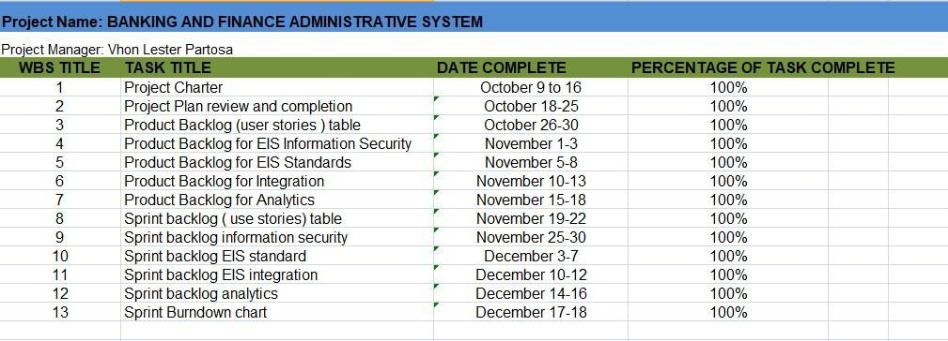

# Stakeholder Strategy

* + - 1. **Introduction**

The Stakeholder Management Strategy for system will be used to identify and classify Administrative system stakeholders; determine stakeholder power, interest, and influence; and analyze the management approach and communication methodology for system stakeholders. This will allow us to identify key influential stakeholders to solicit input for system planning and gain support as the system progresses. This will benefit the Administrative system by maximizing the resources required to successfully develop the system. Early identification and communication with stakeholders are imperative to ensure the success of the system by gaining support and input for the system. Some stakeholders may have interests which may be positively or negatively affected by the system. By initiating early and frequent communication and stakeholder

management, we can more effectively manage and balance these interests while accomplishing all the given tasks.

# Identify stakeholders

The researcher will conduct a brainstorming session in order to identify stakeholders for the system. The brainstorming session will include the primary Banking stakeholder team and project sponsor. These stakeholders may include:

# User

The user can easily access and manage this system because of user-friendly graphical user interface

# Company

The proposed system makes the company’s work easy in systematic way that helps the production work fast and reliable

# System Department

The proposed system will help the department using accurate processing of the system. Using the proposed system, the department will easily handle the issues, concern and problems of the employees.

# Developer

The proponents will be able to complies all the partial fulfillment of their requirements and will broaden their knowledge about the module and the process of the whole Banking system

# Key stakeholders

As a follow on to Identify Stakeholders, the developers will identify key stakeholders who have the most influence on the system or can affect the performance of the company. These key stakeholders are those who also require the most communication and management which will be determined as stakeholders are analyzed. Once identified, the Researcher will develop a plan to obtain their feedback on the level of participation they desire, frequency and

type of communication, and any concerns or conflicting interests they have. Based on the feedback gathered by the Researcher, the determination may be made to involve key stakeholders on steering committees, focus groups, gate review. Thorough communication with key stakeholders is necessary to ensure all concerns are identified and addressed and that resources for the system remain available

# Stakeholder analyst

Once all the Banking and Finance system stakeholders have been identified, the researchers will categorize and analyze each stakeholder. The purpose of this analysis is to determine the stakeholders’ level of power or influence, plan the management approach for each stakeholder, and to determine the appropriate levels of accessibility and participation each stakeholder will have on the system. The researchers will categorize stakeholders based on their organization or department. Once all stakeholders have been categorized, the researchers will utilize a power/interest matrix to illustrate the potential impact each stakeholder may have on the system. Based on this analysis the researchers will also complete a stakeholder analysis matrix which illustrates the concerns, level of involvement, and management strategy for each stakeholder.

|  |  |  |  |
| --- | --- | --- | --- |
| **KEY** | **ORGANIZATION** | **POWER (1-5)** | **INTEREST (1-5)** |
| A | Company | 5 | 3 |
| B | Department | 3 | 3 |
| C | User | 4 | 4 |
| D | Developer | 2 | 2 |

***Table 8. Stakeholder analyst***

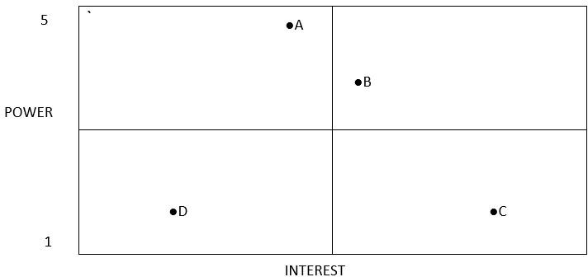

***Table 9. Stakeholder analyst***

Because they are in the lower quadrant of the matrix, stakeholders D will require minimum management effort, according to the power and interest analysis and graphic above. Stakeholder A, located in the upper right quadrant, must be kept happy by ensuring that his or her complaints and queries are effectively addressed. Stakeholder C, in the lower right quadrant, must be kept up to date on project status and progress by frequent contact. Stakeholders A and B, shown in the upper right quadrant, are important participants who must be involved at all stages of project planning and change management.

Based on the stakeholder analysis and power/interest matrix above, the stakeholder analysis matrix will be utilized to record stakeholder concerns, level of involvement, and management strategy. Throughout the project's life cycle, the stakeholder analysis matrix will be reviewed and updated to reflect any new concerns or stakeholder management strategy initiatives.

# Project Planning

* + 1. **Project management plan**
       1. **Introduction**

The Project Management plan is a formal approved document used to manage project execution. The Project Management plan document the action is necessary to define, prepare, integrate and coordinate the various planning activities. The project management plan defines how the project is executed monitored and controlled, and closed. It is progressively elaborated by updates, throughout the course of the project.

# Project management approach

The traditional approach assumes that the project scope and goals will remain constant till project completion. The project team will consist of personnel from the coding group, quality control/assurance group, technical writing group, and testing group. The Project Manager will work with all resources to perform project planning. All funding decisions will also be made by the project sponsor. All project and subsidiary management plan will be reviewed and approved by the project sponsor. Any delegation of approval authority to the project manager should be done in writing and be signed by both the project sponsor and project manager.

# Project Initiation

Is the 1st phase in the Project Management Plan Life Cycle, as it involves starting up a new project you can start a new project by defining its objectives, scope, purpose and deliverables to be produce.

# Project Planning and Design

Project Planning is part of project management which relates to the use of schedules such as Gantt charts to plan and subsequently report progress within the project environment. Initially, the project scope is defined in the appropriate methods for completing the project is determined.

# Project Monitoring

The monitoring and controlling process overseas all the tasks and metrics necessary to ensure that the approved and authorized project is within scope, on time and on budget so that the project proceed with minimal risk.

# Project Execution

Is the phase in which the plan designed in the prior phases of the project life is put into action. The purpose of the project execution is to deliver the project expected results.

# Project Completion

Is often the most neglected phase of the project life cycle. Once the project is over its easy to pack things up throw some files in a drawer and start moving right into the initiation phase of the next project.

# Project scope

The scope of this project includes the planning, design, development, testing, coding and transition of Administrative system. This software will meet or exceed organizational software standards and additional requirements established in the project charter. The scope of this project also includes completion of all documentation, opportunity for exercising the faculties or abilities, range of view, perception or outlook, manuals, and training aids to be used in conjunction with the software. Project completion will occur when the software and documentation package has been successfully executed and transitioned.

All Administrative system project work will be performed internally and no portion of this project will be outsourced. The scope of this project does not include any changes in requirements to standard operating systems to run the software, software updates or revisions.

# Milestone list

The below chart lists the major milestones for the Administrative system project. This chart is comprised only of major project milestones such as completion of the project phase, or gate review. If there are any scheduling delays which may impact a milestones or delivery date, the project manager must be notified immediately so proactive measures may be taken to mitigate slips in dates. Any approved changes to these milestones or date will be communicated to the project team by the project manager.

|  |  |  |  |
| --- | --- | --- | --- |
| **Milestone No.** | **Milestone Description Date** | | |
| No. 1 | Complete requirements gathering | All requirements for Administrative system must be  determined to base design  upon. | October 16, 2021 |
| No. 2 | Complete Administrative System design | This section is for design of system for the software and its functionality. | October 20, 2021 |
| No.3 | Complete  Administrative system coding | All coding completed in a software prototype. | November 10,  2021 |
| No.4 | Complete Banking and Finance (Administrative) system testing  and debugging | All functionality tested and all identified errors corrected. | March 12, 2022 |
| No.5 | Complete Banking and Finance  (Administrative) | Completed software and documentation | April 26, 2022 |

|  |  |  |  |
| --- | --- | --- | --- |
|  | system implementation | for implement the project system |  |
| No.6 | Complete | The completed software | May 05, 2022 |
|  | transition of | and documentation have |  |
|  | Administrative | been sent to the operations |  |
|  | System to | department |  |
|  | Banking and |  |  |
|  | Finance |  |  |

***Table 10. Milestone list***

* + - 1. **Schedule baseline and WBS**

The WBS for the Administrative system project is comprised of work packages with the given proper time of work by the team development. Work packages were developed through close collaboration among project team members and stakeholder with input from functional managers and research from past projects. The WBS dictionary consist of all work packages for the administrative project. This includes all tasks, resources, and deliverables. The administrative system project schedule was based on the WBS and project charter with an input from all project team members. The schedule was reviewed and approved by the project sponsor. The schedule will be maintained by the project manager. Any proposed changes to the schedule will be in the approval of project sponsor. The project manager and team will determine the impact of the change on the schedule, cost, resources, scope, and risk. If the change is approved by the project sponsor then it will be implemented by the project manager who will update the schedule and all documentation and communicate the change to all stakeholders.

# Change management plan

The Following steps comprise the project team change control process for all project and will be utilized on the Administrative project.

Change management plan

Step #1: Identify the need for a change (any Stakeholder)

Requestor will submit a completed changes request from to the project manager.

Step #2: Log change in the changes request register (Project Manager)

The project manager will maintain a log of all change requests for the duration of the project.

Step #3: Conduct an analysis of the changes (Project Manager, Project Team, Requestor)

The project manager will conduct an evaluation of the impact of the change to cost, risk, schedule and scope.

Step #4: Submit Change request to (Project Manager)

The project manager will submit the change request and analysis to all the project team and stakeholders.

Step #5: Project team and stakeholder’s decision

The project manager will discuss the proposed change and decide whether it will be approved on all submitted information.

Step #6: Implement change (Project Manager)

If a change is approved by the project team and stakeholders, the project manager will update and re-baseline project documentation as necessary as well as ensure any changes are communicated to re team and stakeholders.

# Communication Management Plan

This Communications Management Plan sets the communications framework for the system. It will serve as a guide for communications throughout the life of the project and will be updated as communication needs change. This plan identifies and defines the roles of persons involved in this project. It also includes a communications matrix which maps the communication requirements of this project. An in-depth guide for conducting meetings details both the communications rules and how the meetings will be conducted, ensuring successful meetings. A project team directory is included to provide contact Information for all stakeholders directly involved in the project.

All project communication activities will occur within the project’s approved budget, schedule, and resource allocations. The project manager is responsible for ensuring that communication activities are performed by the project team and without external resources which will result in exceeding the authorized budget. Communication activities will occur in accordance with the frequencies detailed in the Communication Matrix in order to ensure the project adheres to schedule constraints. Any deviation of these timelines may result in excessive costs or schedule delays and must be approved by the project sponsor.

|  |  |  |  |  |  |
| --- | --- | --- | --- | --- | --- |
| **Communica tion types** | **Description Frequ**  **ency** | **Format** | **Participant s/**  **Distributio ns** | **Delivera bles** | **Owner** |

|  |  |  |  |  |  |  |
| --- | --- | --- | --- | --- | --- | --- |
| Weekly Project  Team meeting | Meeting to  create and  gather data about the assigned system. | Weekl y | Overnig ht | Project Team | Status Report | Project Manager |
| Weekly status report | Another  meeting to update the documentatio n and  brainstorming about the  system process and  connection. | Weekl y | As needed | Project team | Review the status of docume nts and the system. | Project Manager |
| Project monthly review | Present status to team and sponsor | Monthl y | As needed | Project team  Project  Adviser | Status and Present ation | Project Manager |
| Technical design review | Review of any technical design or  work associated with the  project | Weekl y | As needed | Project team | Technic al design package | Project Manager |

***Table 11. Communication Management Plan***

**Project team directory for all communications is:**

|  |  |  |  |
| --- | --- | --- | --- |
| **Name** | **Title** | **E-mail** | **Cell phone number** |
| Dela Cruz, Kimberly | System  Analyst | kimberlydelacruz058@gm ail.com | 09352423007 |
| Partosa, Vhon Lester | Project  Manager | [partosavhon5@gmail.com](mailto:partosavhon5@gmail.com) | 09053236118 |
| Gabule, Dexter | Programmer | [Lilgabs08@gmail.com](mailto:Lilgabs08@gmail.com) | 09098374504 |
| Amatos, Jean Rose | Business  Analyst | amatosjeanne511@gmail.  comm | 09272207347 |
| Parael, Shalomae | Document  Specialist | [paraelshalomae@gmail.c](mailto:paraelshalomae@gmail.c) om | 09777123244 |

***Table 12. Project team directory for all communications* conduct Meetings:**

The project manager will distribute a meeting agenda at least early prior to any schedule meeting in all participant must comply and review agenda prior to the meeting. During all project meetings, all information and agenda will take notes this must be the record for the team’s concern.

# Email:

All email pertaining the Administrative system project should be professional, active, can provide brief communication. Email should be distributed to the correct project participant in accordance with the communication matrix above based on its content. All attachment should be in one organization’s standard software suite programs and adhere to established company format.

# Informal communications:

Any issue, concerns, or status that arises from informal communications between team members must be communicated to the project manager so the appropriate actions may be taken.

# Cost management plan

The Project Manager will be responsible for managing and controlling the project's costs and will have the power to do so. The project manager must be kept up to speed on cost performance and offer status or updates on its calculations throughout the project's life cycle. Because the Project Sponsor is in control of all budget authorization, choices, and modifications, the project manager must deliver it to him.

|  |  |  |
| --- | --- | --- |
| **Fixed Cost** | | |
| **Budget Item** | **Description** | **Budgeted Cost** |
| Project Study Fee | Individual fee share costs, which must be paid by all members of the group in order to qualify for defense. | 7,500php |
| Miscellaneous | It includes food, transportation, electricity, and Wi-Fi, which are the project team's essential requirements. | 15,000php |
| **Total Fixed Cost 22,500php** | | |

***Table 13. Cost management plan***

* + - 1. **Procurement Management Plan**

This Procurement Management Plan sets the procurement framework for Administrative system. It will serve as a guide for managing procurement throughout the life of the project and will be updated as acquisition needs change. This plan identifies and defines the items to be procured, the types of contracts to be used in support of this project, the contract approval process, and decision criteria. The Project Manager will manage for all procurement activities under this project. The Project Manager is authorized to approve all procurement actions up to 10,000. Any procurement actions exceeding this amount must be approved by the Project Sponsor.

# Project scope management plan

The Project Scope Management of Administrative System follows a five-step process; Collect Requirements, Define Scope, Create WBS, Verify Scope, and Control Scope.

Collect Requirements –The foundation of this process is the project charter and stakeholder register. From these, the team can identify requirements, collectively discuss details associated with meeting each requirement, conduct a survey and follow-on discussion to clarify the requirements, and document the requirements in sufficient detail to measure them once the project begins the execution phase. This documentation also serves as an input to the next step in the process which is to define scope.

Define Scope – this step is critical to project success as it requires the development of a detailed project/system description to include deliverables, assumptions, and constraints and establishes the framework within which project work must be performed.

Create WBS – this process breaks project deliverables down into progressively smaller and more manageable components which, at the lowest level, are called work packages. This hierarchical structure allows for more simplicity in scheduling, costing, monitoring, and controlling the project.

Verify Scope – this is the process by which the project team receives a formalized with the sponsor and/or customer.

Control Scope – this is the process of monitoring/controlling the project/product scope as well as managing any changes in the scope baseline. Changes may be necessary to the project scope but it is imperative they are controlled and integrated in order to prevent scope creep.

# Schedule management plan

Project schedules will be created using the state standard scheduling tool starting with the deliverables identified in the project’s Work Breakdown Structure (WBS). Activity definition will identify the specific work packages which must be performed to complete each deliverable. Activity sequencing will be used to determine the order of work packages and assign relationships between project activities. Activity duration estimating will be used to calculate the number of work periods required to complete work packages. Resource estimating will be used to assign resources to work packages in order to complete schedule development.

Once a preliminary schedule has been developed, it will be reviewed by the project team and any resources tentatively assigned to project tasks. The project team and resources must agree to the proposed work package assignments, durations, and schedule. Once this is achieved the project sponsor will review and approve the schedule and it will then be baselined.

The following will be designating as milestones for the project schedule:

* Completion of scope statement and WBS/WBS Dictionary
* Baselined project schedule
* Approval of final project budget
* Project kick-off
* Approval of roles and responsibilities
* Requirement’s definition approval
* Completion of data mapping/inventory
* Project implementation
* Acceptance of final deliverables

# Quality management plan

The project team ensures the quality of the proposed system through evaluation and testing. By evaluation it helps determine what works well and what could be improved in a program or initiative and it help the project team to understand and document the desired outcome of the development system. And by testing the system it will detect software failures so that defects may be discovered and corrected and to ensure that the system meets its specification.

# Risk management plan

|  |  |  |  |
| --- | --- | --- | --- |
| **Risk** | **Probability**  **(H-M-L)** | **Impact**  **(H-M-L)** | **Risk Management Action** |
| Technical Risks | M | M | Having an extra unit that can be used if that other units collapsed. |
| Financial Risk | M | M | The Project Team will have a fund for some expenses in doing the project |

|  |  |  |  |
| --- | --- | --- | --- |
| Calamity Risks | M | M | The team used the power of technology to have a communication even if it is far from each other due to bad weather. |
| User Risks | L | M | Providing user manual for the user. |
| Software Risks | H | M | Always having a backup file |
| Security Risks | H | H | Creating a login form to avoid unwanted users in accessing the system |
| Operational Risks | M | M | The company must provide staff or personnel that appropriate to use the system |

***Table 14. Risk Management Plan***

* + - 1. **Risk Register**

The risk register for this project is a list of all risks that have been identified their probability and impact to the project, the category to which they belong, mitigation strategy, and when the risk will occur. The register was created during the initial project risk management meeting, which was led by the project manager. During this meeting, the project team identified and classified each risk.

Furthermore, the team assigned a score to each risk based on the probability of it occurring and the potential impact. The Risk Register also includes a mitigation strategy for each risk, just as it is likely to occur. Each risk has been added to the project plan based on the identified risks and timeframes in the risk register. At the appropriate time in the plan—prior to when the risk is most likely to occur— the

project manager will appoint a risk manager to ensure adherence to the agreed upon mitigation strategy. Each risk manager will provide an update on the status of their assigned risk during the bi-weekly project team meeting for their risk’s planned timeframe.

# Staffing Management Plan Project manager

Project managers play the lead role in planning, executing, monitoring, controlling and closing projects. They are accountable for the entire project scope, project team, resources, and the success or failure of the project.

A project manager, with the help of their team, is charged with multiple responsibilities that span the five project phases of a project life cycle (initiating, planning, executing, monitoring and closing).

The project management phases intersect with 10 knowledge areas. The knowledge areas include integration, scope, time, cost, quality, human resources, communication, risk procurement and stakeholder management.

# Programmer

It is the person who is responsible for coding. He also involved in maintaining, debugging, and troubleshooting.

# System Analyst

This person is responsible for analyzing, designing and implementing system to fulfill organizational needs.

# Business analyst

The business analyst takes ultimate responsibility for identify and solving problems affecting the business solution, and works closely with the project manager to

analyze the existing business systems and make recommendations for improvement.

# Document specialist

This is the person who is responsible in documenting all the activities and all things that are related in creating the project. Encodes all collected and research documents.

# Cost Baseline

The cost baseline for the Administrative system project includes all budgeted cost for the successful completion of the project**.**

|  |  |  |
| --- | --- | --- |
| **Project Phase Budget Total** | | **Comments** |
| Planning | 500 | It is the section where the group will plan in gathering information and requirements to get the project done. |
| Design | 1,000 | It’s for the proposed system graphics and design of what the system would look like**.** |
| Coding | 2,000 | Includes all work hours for coding. |
| Testing | 1,000 | Includes all work hours for testing of the system |
| Implementation | 1,000 | Includes all work hours for  implementing the system |
| Transition and  Closeout | 1,000 | Includes all work hours for transition to operations and project closeout. |

***Table 15. Cost Baseline***

* + - 1. **Quality Baseline**

|  |  |  |
| --- | --- | --- |
| **Item** | **Acceptable Level** | **Comments** |
| Collection and Generate reports | At least 98% working with 2% or less errors |  |
| Compatibility | No errors associated with  running software with compatible applications | Using the suite of applications |
| Supporting  Documentation | All documentation will be in completion |  |

***Table 16. Quality Baseline***

* + 1. **Risk management plan**
       1. **Introduction**

This section explains why risks existed and highlights the purpose and importance of the risk management plan. It provides the general description why risk management is essential to effectively managing a project and describes what is needed before risk management can begin.

As organizations begin new project, they begin operating in an area of uncertainty that comes along with developing new a unique products or services. These organizations take chances which results in risk playing a significant part in any project. The purpose of the risk management plan is to establish the framework in which the project team will identify risks and develop strategies to mitigate or avoid those risks. Before risks can be identified and managed, there are preliminary projects elements which must be completed. These elements are outlined in the risk management approach.

# Top three risk

The top three high prospect and high influence risks to this project are:

# Delay internet connection Operational Risks

It is mostly occurred when team structure is not clear, and the work environment prone to be toxic. It leads to a situation when a team member will not be able to pursue the project or achieve software development goals.

# Test and integration

It is also a big problem to test the software with real data, and to integrate different modules.

# Risk management approach

The approach we have taken to manage risk for this project included a methodical process by which the project team identified, scored, and ranked the various risk. The most likely and highest impact risks were added to the project schedule to ensure that the assigned risk managers take the necessary steps to implement the mitigation response at the appropriate time during the schedule. Risk managers will provide status updates on their assigned risks and the bi-weekly project team meetings, but only when the meeting include their risks planned timeframe. Upon the completion of the project, during the closing process, the project manager will analyze each risk as well as the risk management process. Base on this analysis, the project manager will identify any improvements that can be made to the risk management process for future projects. This improvement will be captured as part of the lessons learned knowledge based.

# Risk identification

For this project risk identification was conducted in the initial project risk assessment meeting. The method uses by the project team to identify risk was the

Crawford Slip method. The project manager chaired the risk assessment meeting and distributed notepads to each member of the team and allowed 10 minutes for all team members to record as many risks as possible.

# Expert Interview

Two expert interviews were held for this project. The interviews revealed several risks which were then mitigated by making changes to the project plan. The remaining risks are included in the risk register.

# Risk assessment meeting

A risk assessment meeting was held with key team members and stakeholders. The risk identified during this meeting was added to the project plan and this risk register.

# Historical review of similar projects

The project team reviewed the history of similar projects in order to determine the common risk and the strategies used to mitigate those risks.

# Risk Qualification ad Prioritization

In an effort to distinguish the severity of the risks raised by the team, a probability and impact factor was assigned to each of the risks. This procedure allowed the project manager to prioritize risks based on the effect they may have on the project. The project manager utilized a probability-impact matrix to help the team in determining each risk to its appropriate place on the chart.

After assigning the risks’ probability and impact and placing them in their appropriate position on the chart, the recorder captured the finished product and the project manager moved the process to the next level: risk mitigation/avoidance planning.

# Risk Monitoring

The most likely and greatest impact risks have been added to the project plan to ensure that they are monitored during the period of the project's risk exposure. At the appropriate time in the project schedule a Risk Manager is assigned to each risk. During the two-week project team meetings, The Risk Manager for each risk will discuss the status of that risk. However, only risks that

occur during the current time period will be discussed. Risk monitoring will be an ongoing procedure over the duration of this project. As risks approach on the project schedule, the project manager will ensure that the appropriate risk manager provides the essential status updates, that includes risk status, identification of trigger conditions, and the documentation of the risk response's outcomes

# Risk Mitigation and Avoidance

The project manager led the project team in developing responses to each risk. As more risks are identified, they are verifying and the team will develop the avoidance and mitigation strategies. These risks will also be added to the Risk Register and the Project Plan to be monitored promptly and responded accordingly.

The risks for this project will be managed and controlled within the constraints of time, scope, and cost. All identified risks will be evaluated in order to determine how they would affect these constraints. The project manager, with the project team, will determine the best way to respond to each risk to make certain of the compliance with these constraints.

In extreme cases it would be necessary to allow flexibility on one these constraints. Only one of the constraints of this project will be allowed flexibility as a last resort. If needed, funds can be added to the project to allow more resources to meet the time (schedule) and scope constraints. Time and scope are firm constraints and allow no space for flexibility. Again, cost constraint is only flexible in extreme cases wherein no other risk avoidance or mitigation strategy will work.

# Risk Register

The risk register for this project is a list of all risks that have been identified their probability and impact to the project, the category to which they belong, mitigation strategy, and when the risk will occur. The register was created during the initial project risk management meeting, which was led by the project manager. During this meeting, the project team identified and classified each risk.

Furthermore, the team assigned a score to each risk based on the probability of it occurring and the potential impact. The Risk Register also includes a mitigation strategy for each risk, just as it is likely to occur. Each risk has been added to the project plan based on the identified risks and timeframes in the risk register. At the appropriate time in the plan—prior to when the risk is most likely to occur— the project manager will appoint a risk manager to ensure adherence to the agreed upon mitigation strategy. Each risk manager will provide an update on the status of their assigned risk during the bi-weekly project team meeting for their risk’s planned timeframe.

# Scope management plan

* + - 1. Introduction

The Scope Management provides the scope framework for this project. This organizes documents the scope management approach; roles and responsibilities as they pertain to the project scope statement; scope verification; scope control; and to boot the work breakdown structure of the project. Any project communication that concerns with the project’s scope will have to compel to adhere to the Scope Management created.

This project is for proffering of, programming, and replacement wares testing that can be accustomed to improve generating of assortment reports. This includes kind of the package, all programming and writing, and testing/validation of the package. No external resources or outsourcing unit anticipated for this project.

# Scope management approach

For this project, scope management will be the sole responsibility of the Project Manager. The scope for this project is defined by the Scope Statement, Work Breakdown Structure (WBS) and WBS Dictionary. The Project Manager, Sponsor and Stakeholders will establish and approve documentation for measuring project scope which includes deliverable quality checklists and work performance measurements. Proposed scope changes may be initiated by the Project Manager, Stakeholders or any member of the project team. All change requests will be submitted to the Project Manager who will then evaluate the requested scope change. Upon acceptance of the scope change request the Project Manager will submit the scope change request to the Change Control Board and Project Sponsor for acceptance. Upon approval of scope changes by the Change Control Board and Project Sponsor the Project Manager will update all project documents and communicate the scope change to all stakeholders. Based on feedback and input from the Project Manager and Stakeholders, the Project Sponsor is responsible for the acceptance of the final project deliverables and project scope.

# Roles and responsibilities

The Project manager, sponsor and team can all play key roles in managing the scope of this project. As such, the project sponsor, manager, and team members got to bear in mind their responsibilities so on the certify that job performed on the project is among the established scope throughout the whole quantity of the project. The table below defined the roles and responsibilities for the scope management of this project.

|  |  |  |
| --- | --- | --- |
| **Role** | **Description** | **Name** |

|  |  |  |
| --- | --- | --- |
| **Project Sponsor** | -He is responsible to approve and deny scope change requests as appropriate.  -Evaluate need for scope change requests  -Accept project deliverables | Mr. Enrico Pineda |
| **Business Analyst** | A person who analyzes an organization and documents its business, process, and system | Amatos, Jean Rose |
| **Project Manager** | Manage the whole team and the whole process | Partosa, Vhon Lester |
| **Programmer** | A person who is responsible for coding. He also involved in maintaining, debugging, and troubleshooting. | Gabule, Dexter |
| **Document Specialist** | This is the person who is responsible in documenting all the activities and all things that are related in creating the project.  Encodes all collected and research documents. | Parael, Shalomae |
| **System Analyst** | This person is responsible for analyzing, designing and implementing system to fulfill organizational needs. | Dela Cruz, Kimberly |

***Table 17. Roles and responsibilities***

* + - 1. **Scope definition**

The scope for this project was defined through a comprehensive requirements collection process. From this information, the project team developed the project requirements documentation, the requirements management plan, and the requirements traceability matrix for what the new software application must accomplish.

The project description and deliverables were developed based on the requirements collection process and input from subject matter experts in software design, technical support, programming and business applications. This process of expert judgment provided feedback on the most effective ways to meet the original requirements of providing a new software platform from which the company can improve its financial tracking and internal financial processes.

# Project scope statement

The project scope statement provides a detailed description of the project, deliverables, constraints, exclusions, assumptions, and acceptance criteria. Additionally, the scope statement includes what work should not be performed in order to eliminate any implied but unnecessary work which falls outside the of the project’s scope.

* Product scope description- this will describe what the project will accomplish
* Product Completion/ Acceptance Criteria-describes what

requirements must be met in order for a project to be accepted as complete

* Risk Assessment- describe the top two or three projects risk and a high-level mitigation plan. This brief assessment will be expanded in the formal risk management plan.
* Project Deliverables-detailed list of deliverables the projects will result in.
* Project Exclusions (out of scope)-description of work that is not included in the project and outside of the scope.
* Dependency linkages- in some cases may be dependent upon

another project’s deliverables, this linkage needs to be identified and its progress monitored. In other cases, a project may be dependent upon information from other agencies; he tasks and activities of the information gathering process need to be monitored.

* + - 1. ***WBS Table 18. WBS***

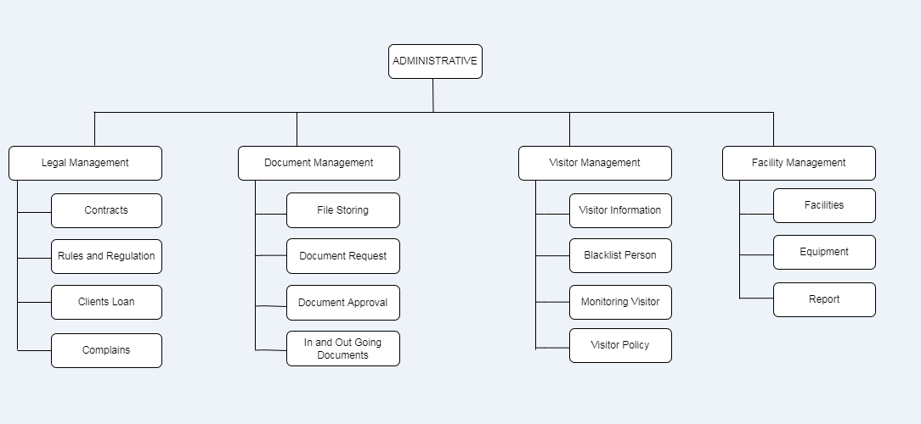

***Table 18. WBS***

* + - 1. **Scope verification**

As this project progresses the Project Manager will verify interim project deliverables against the original scope as defined in the scope statement, WBS and WBS Dictionary. Once the Administrative Project Manager verifies that the scope meets the requirements defined in the project plan, the Project Manager and Sponsor will meet for formal acceptance of the deliverable.

During this meeting the Project Manager will present the deliverable to the Project Sponsor for formal acceptance. The Project Sponsor will accept the deliverable by signing a project deliverable acceptance document. This will ensure that project work remains within the scope of the project on a consistent basis throughout the life of the project.

# 1.2.3.7 Scope control

If a change to the project scope is needed the process for recommending changes to the scope of the project must be carried out. Any project team member or sponsor can request changes to the project scope. All change requests must be submitted to the Project Manager in the form of a project change request document. The Project Manager will then review the suggested change to the scope of the project. The Project Manager will then either deny the change request if it does not apply to the intent of the project or convene a change control meeting between the project team and Sponsor to review the change request further and perform an impact assessment of the change. If the Change Control Board approves the scope change the Project Sponsor will then formally accept the change by signing the project change control document. Upon acceptance of the scope change by the Change Control Board and Project Sponsor the Project Manager will update all project documents and communicate the scope change to all project team member stakeholders.

# Project Execution plan

* + 1. **Implementation and migration plan**
       1. **Purpose**

Implementation and Migration Plan has been developed the Administrative system on how the system ensure its security, reliability and functionality. This project will be implemented, installed and migrated to its operational environment hand over to the Bestlink College of the Philippines. The purpose of this plan is to ensure all stakeholders are aware of the details, requirements, and responsibilities involved in successfully completing this project and migrating the product to the operational group. Any requested changes to this plan should be submitted through the project’s change control process for review and approval prior to implementation.

# Description of implementation

The Administrative system will be implemented at Bestlink College of the Philippines as part of the requirements. This project has different sub-modules: Legal Management, Document Management, Facility Management and Visitor Management.

For the system implementation, they need samples for testing and evaluation thus, they need to ensure that the databases will work properly. This description of implementation provides all stakeholders with a detailed understanding of how implementation will take place. Once the Administrative database design is complete, a beta version of the database will be uploaded to the institute. The team collects all existing data from the existing database and loads that data into the Administrative database to test data integrity and compatibility between the way maintenance data is collected and the new database. Once the test has been completed and the functionality of the Administrative database has been verified, operator training will be carried out with maintenance personnel for the new tool. Upon completion of the training, the Administrative database will be uploaded to the institute's maintenance servers and partitioned to prevent user access. The

institute department then verifies the functionality of the database on the actual servers.

As soon as functionality is confirmed on the maintenance servers, a notification is distributed to the entire organization, communicating the transition from the old maintenance database to the new Administrative database. At this point, the maintenance staff, in collaboration with the IT group, performs a final data collection of all the maintenance data in the legacy system, and the IT group imports the data into the Administrative database. As soon as the data import has been classified as successful by the IT group, the old system will be deactivated. At this point, a manual emergency procedure is performed in which maintenance technicians manually record all maintenance activities over a two-day period while preparing the Administrative database for commissioning. After approval by the IT group, the teller database is put into operation for a period of 48 hours by maintenance technicians with the support of the IT group to ensure acceptance criteria are met. As soon as the team has verified whether the acceptance criteria have been met, the manually recorded maintenance data is entered into the Administrative database. Completion of manual data entry and achievement of acceptance criteria formally ends the implementation phase of this project.

# Points of contact

The Administrative Database Project spans several different Institute’s and is an extremely fluid and technical project. As such, it is crucial to acknowledge the points of contact for the several characteristics of this project. The chart below gives all stakeholders with the points of contact should any urgent questions or concerns arise. All stakeholders should ensure their communications are compliant with the Administrative system Database Project Communications Plan.

|  |  |  |
| --- | --- | --- |
| **NAME** | **ROLE** | **CONTACT**  **INFORMATION** |
| Partosa, Vhon Lester | Project Manager | 09053236118 |

|  |  |  |
| --- | --- | --- |
| Gabule, Dexter | Programmer | 09098374504 |
| Dela Cruz, Kimberly | System Analyst | 09428574556 |
| Amatos, Jean Rose | Business Analyst | 09272207347 |
| Parael, Shalomae | Document Specialist | 09572545635 |

***Table 19. Points of contact***

* + - 1. **Major task**

The Administrative system project team has developed a list of major tasks required to successfully Implement and migrate this project. All of these tasks have been vetted by the project team to ensure they are within the scope of this project. Additionally, all major tasks have been assigned to the responsible individuals and/or groups and communicated to all stakeholders. The list of major tasks for the project systems are:

* Complete system design: IT Department

This task includes completion of all design and graphics work for the new database.

* Complete testing: IT Department

This task involves the successful testing of the Database in the virtual testing environment

* Complete Functionality on Maintenance Servers: IT Department

This task involves the IT Group loading the database onto the maintenance servers and testing

* Complete data Capture: IT Department

This task involves capturing all existing maintenance data from the legacy database to the system.

* Operational Acceptance: Maintenance Operations Group

This task involves formal acceptance of the system Database by the Maintenance Operations Group.

# Implementation Schedule

The implementation schedule for the Administrative system is provided below.

|  |  |
| --- | --- |
| **Task/ Milestone** | **Schedule Completion date** |
| Project Planning | **10/10/21** |
| Project Design | **11/4/21** |
| Coding or development | **03/13/22** |
| Testing | **04/21/22** |

***Table 20. Implementation Schedule***

* + - 1. **Security**

The Institute's information technology security measures are established and implemented through the institute's IT department. The Banking and Finance system database will remain behind the university's existing firewall and security measures managed by the IT department's security administrator. While no special or additional security measures will be implemented for legacy databases, the security administrator will be involved in the design, testing, implementation, and migration of all steps. Additionally, once the Banking and Finance system database has been removed for operational use, it will be monitored by the security administrator, along with other IT tools, to ensure ongoing compliance with the institute.

# Implementation Support

The Banking and Finance system project will require a moderate level of support from the institution of Bestlink College of the Philippines. The groups directly involved in providing support for this project are the College of Computer Studies (CCS), the Maintenance Operations Group, and the IT Group. The Project Manager will facilitate all meetings and discussions in completing the tasks for this project. The Project Manager will work directly with both the IT Group and the Maintenance Operations Group to complete these tasks. With feedback and requirements from the Operations Maintenance Group, the IT Group will design, test, and implement the Banking and Finance System on both the virtual testing servers and the maintenance servers. The IT Group will also develop and provide training to maintenance operators on the system. These tasks will be done by the lead and assistant IT engineers. If additional support is needed, it will be coordinated through the Project Manager and IT Group Lead. The Maintenance Operations Group will provide all operational requirements to the IT Group for inclusion in the design and implementation of the software. The Maintenance Operations Group will also be required to provide feedback on testing. Additionally, all maintenance operators will participate in system training. If additional support is needed, it will be coordinated with the Project Manager and the Maintenance Division Lead.

# Listing of hardware, software and facilities

The Banking and Finance system project requires a database design on where the existing database resides. While this allows improved functionality and capability, it does not require any additional hardware or upgrades to existing hardware. Likewise, no additional facilities are required to complete the implementation and migration of this project. This project will be completed within the existing capabilities of current facility.

# Performance Monitoring

The Banking and Finance system will provide not only the same capabilities as ordinary software can do, but additional functionality as well. As such, these additional functions have been included by the design team in planning for ongoing performance monitoring of the security of using the system. To accomplish this, additional monitoring criteria have been added to the operational environment to collect real-time data once the database is migrated to its operational environment. The Maintenance Operations Lead is responsible for monitoring performance and producing weekly reports which will be provided not only to the Banking and Finance management team, but to the IT Group Lead as well. If the Banking and Finance performance security indicates any database performance outside of the acceptable levels, the issue will be escalated immediately to the Banking and Finance staff leads to determine and execute corrective measures and initiate a root cause analysis. This is the existing procedure of the team. Utilizes for all IT tools.

# Implementation Requirements (Hardware/Software/ Personnel/ Facilities/ other capital investment:

For the Banking and Finance Project, the project team and stakeholders have completed their requirements gathering activities. As this is a small to moderately sized project, and will be completed internally with no contract or external support, the list of requirements is very specific and manageable. The following list represents the requirements necessary for successful implementation of the Banking and Finance system Project: Hardware/Software: Functional virtual testing servers – existing Functional maintenance servers – existing Personnel: Lead IT Engineer – on project team Assistant IT Engineer – on project team Maintenance Division Lead – on project team

Maintenance Operation Lead – on project team

Maintenance Operators – as needed for testing, training, and feedback

Security Administrator – on project team and ongoing operations support

# Personnel

Project Sponsor – Enrico Pineda Project Manager –Vhon Lester Partosa Programmer – Dexter Gabule

System Analyst- Kimberly Dela Cruz

Business Analyst- Jean Rose Amatos Document Specialist- ShalomaeParael

Facilities:

None – utilize existing facilities Other Capital Investments: None – utilize existing resources

# Back Out Plan

During planning for the Banking and Finance System implementation, a risk was identified that the new software may fail once it goes live. To mitigate this risk the project team has developed a back out plan to allow the maintenance group to continue operations should the Banking and Finance launch fail. As the data capture task is conducted, all maintenance data will be updated for both the Banking and Finance System and the institution in loved. The department of College of Computer Studies will help to back up the server until the implementation and operational acceptance are complete. If Banking and Finance System is launched and encounters any problems or failures, the IT Group will immediately remove access for all operational maintenance technicians and restore access to the CSS department. This will allow maintenance operations to continue while troubleshooting and additional testing are conducted on the System Database

# Post Implementation Verification

Once the Banking and Finance System is implemented, several steps will be taken to verify successful implementation. First, operations managers will ensure that all maintenance technicians have access to the software to perform assigned maintenance activities. Once this is verified, managers will ensure their maintenance technicians check their ability to perform all assigned functions in the Banking and Finance System and that the correct permissions and activities are in place. Finally, maintenance managers will query and run all assigned metrics and reports to ensure all required capabilities for the system are met. Upon completion of these activities, maintenance managers will meet with the project team to review all verification activities in a final verification that implementation requirements were successfully.

# Project Closure

* + 1. **Transition-out plan**
       1. **Executive Summary**

The Bestlink of the Philippines Quezon City Branch has seeking to develop a system as a requirement for the IT students to their subjects. The system that we develop is Banking and Finance system where it will ensure the features that the developers provided in terms of Security, Reliability and Functionality. The system will be implemented and governed by the IT Department Of the premise will give by the Development Team. The contract is currently negotiated; Handled and it will take some to decide the operations of the system.

# Transition Approach

For this case, the Development Team will provide the Banking and Finance system and hand over to the Bestlink College of the Philippines. The Staff will test the system and Development Team will maintain the integrity, efficiency and the

troubleshooting of it. The transition will take place in 60 days to finish. Now prior to the transition, the BCP will take a stand to the Development Team will handled all matters necessary for the accomplishment of the transition. As said earlier, the BCP will have its staff assigned at the start of the 60-day transition and it will coordinate with the development team.

# Transition Team Organization

The following chart illustrates the transition team members from Development Team from the IT department of BCP, as well as the roles and responsibilities of each team member.

|  |  |  |
| --- | --- | --- |
| **Title** | **Roles/Responsibilities** | **Organization** |
| **Business Analyst** | A person who analyzes an organization and documents its business, process, and system | Amatos, Jean Rose |
| **Project Manager** | Manage the whole team and the whole process | Partosa, Vhon Lester |
| **Programmer** | A person who is responsible for coding. He also involved in maintaining, debugging, and troubleshooting. | Gabule, Dexter |
| **Document Specialist** | This is the person who is responsible in documenting all the activities and all things that are related in creating the project. Encodes all collected and research documents. | Parael, Shalomae |

|  |  |  |
| --- | --- | --- |
| **System Analyst** | This person is responsible for analyzing, designing and implementing system to fulfill organizational needs. | Dela Cruz, Kimberly |

***Table 21. Transition Team Organization***

* + - 1. **Work Transition**

For this contract transition, all workforce members will stay with their current firm. The BCP Workforce will remain stand-by to execute their transition activities until the time of the transition is accomplished and accepted by all parties. The development team will provide workspace for parties involved until transition is finished.

# Work Execution during Transition

Around the transition of this arrangement, work will be proceeding to be executed by BCP In line with the accepted project schedule and work breakdown structure (WBS) in place. The Development Team will secure the BCP staffs work alongside the parties involved. Nevertheless, BCP maintain all management for the task and deliverables. At the End of the 60-day transition time, upon transition acceptance will take its place.

# Subcontracts

This section lists all of the existing contracts, as well as whether or not they will be migrated. This information (subcontract agreements, software/hardware maintenance contracts, etc.) should be presented in a table fashion.

The chart below shows the subcontracts that are in place to help with Banking Transactions activities. These subcontracts use third-party activities to secure all essential transactions and ensure that the system's functionality is in place.

Transaction’s activity- These subcontracts appeal to third party tasks to secure all required transactions and facilitates functionality is in place to support the system.

# Property Transition

* + - * 1. **Government Furnished Equipment (GFE)**

As a segment of this transition, all GFE provided to BCP will be under a certain contract that will be become into the government over completion and acceptance of the transition phase. GFE comprise of laptop computer, flash and external hard drives. All electronic devices will be assigned by the government IT officer and it will be issued appropriately.

# Incumbent Owned Equipment

All necessary owned equipment will remain with the incumbent upon fulfillment and acceptance of the transition. This equipment includes laptop, organizational tools, maps and etc. if it is deciding that any incumbent owned equipment is need to remain with the client to secure successful accomplishment of the contract, the client and incumbent contracting staff representatives will interrelate attaining of the equipment through the customer’s confirmed procurement management process.

# Intellectual Property

Per the transaction contract, all intellectual property which is a straight result of work on the contract deliverables will be transitioned to the new contractor in order to secure the successful accomplishment of the project. The contract pricing

takes intellectual property into contemplation and as such, any resulting intellectual property will be possessed by the customer**.**

# User Accounts and Passwords

As part of the contract transition, various user accounts accesses and authorizations must be created and disabled. Currently Banking and Finance personnel listed in the chart below possess the user accounts and access necessary for contract deliverables. The listed Banking and Finance employees will be granted on the first day of the contract transition phase. Once transition is completed and approved, all Banking and Finance official’s user accounts will be disabled.

|  |  |
| --- | --- |
|  | **Banking and Finance**  **(Administrative system)** |
| **User Account** |  |
| **Admin** | System Administrator |
| **User** | System User (Client) |
| **Owner** | System User (Owner) |
| **Visitor** | System User (Visitor) |

***Table 22. User Accounts and Passwords***

* + - 1. **Knowledge Transfer**

For this transition, knowledge transfer will occur over the entirety of the 60day transition period. The knowledge transfer will take place via various methods. The incumbent PM will coordinate two formal classroom training sessions to be conducted by the incumbent IT Transition Lead. These sessions will focus on the specific IT concerns related to the database tasks and activities. The incumbent PM will also coordinate two formal classroom sessions to be conducted by the

incumbent Configuration Manager. These sessions will cover documentation requirements and organizational processes and assets. These sessions will be completed no later than 15 days prior to the end of the 60-day transition period. The customer will meet no later than 10 days prior to transition completion in order to determine if any further training or knowledge transfer is required**.**

# Schedule



* + - 1. **Handover and Acceptance**

For this transition, knowledge transfer will occur over the entirety of the 60day transition period. The knowledge transfer will take place via various methods. The incumbent PM will coordinate two formal classroom training sessions to be conducted by the incumbent IT Transition Lead. These sessions will focus on the specific IT concerns related to the database tasks and activities. The incumbent PM will also coordinate two formal classroom sessions to be conducted by the incumbent Configuration Manager. These sessions will cover documentation requirements and organizational processes and assets. These sessions will be completed no later than 15 days prior to the end of the 60-day

transition period. The customer will meet no later than 10 days prior to transition completion in order to determine if any further training or knowledge transfer is required.

# Project acceptance

This project acceptance document establishes formal acceptance of all the deliverables for the Banking and Finance project. The Administrative System project has met all the acceptance criteria as defined in the requirements document and project scope statement. A project audit has been performed to verify that all deliverables meet performance and product requirements. Additionally, a product evaluation has been performed and determined that all products meet the quality and functional requirements defined within this project transition to Operations has been completed. The live system has been handed over to Operations and the transfer of knowledge from the Project Team to Operations has also been completed. All training has concluded and the System Operations Guide has been handed over to Operations. The Project Manager is authorized to continue with the formal close out of this project. The closeout process will include a post-project review, documentation of lessons learned, and release of the Project Team, close out all procurements and archive all relevant project documents. Once the closing process is completed the Project Sponsor will be notified and the Project Manager will then be released from the project.

# Post project review

* + - 1. **Project Summary**

The Banking and Finance (Administrative) system is ongoing.

The purpose of this project is to improve the process and transaction of banking department where it meets the needs and wants of the customer or the client. The proponents will develop a user friendly and apply security measures. The project deliverables shall include the system design, all coding, testing, implementation of

an integrated system for use with existing IT infrastructure and a user’s guide. The objectives of the Banking and Finance (Administrative) are to create a system that is easy to use, user-friendly, reliability and flexible that can provide and make the task of the administrative to be easier.

# Project Team and Staffing

|  |  |  |
| --- | --- | --- |
| **Role** | **Names** | **Roles/Responsibilities** |
| Business Analyst | Amatos, Jean Rose | A person who analyzes an organization and documents its business, process, and system |
| Project Manager | Partosa, Vhon  Lester | Manage the whole team and the whole process |
| Programmer | Gabule, Dexter | A person who is responsible for coding. He also involved in maintaining, debugging, and troubleshooting. |
| Document Specialist | Parael, Shalomae | This is the person who is responsible in documenting all the activities and all things that are related in creating the project.  Encodes all collected and research documents. |
| System Analyst | Dela Cruz, Kimberly | This person is responsible for analyzing, designing and implementing system to fulfill organizational needs. |

|  |  |  |
| --- | --- | --- |
| Project Sponsor | Mr. Enrico Pineda | •Make business/ approach decisions for the projects.  •Participate in key activities  •Make resources available |
| Advisor and Resources | Mr. Andy Adovas | •Responsible to check and monitor the improvement of all the document and system. |

***Table 23. Project Team and Staffing***

* + - * 1. **Project Deliverable (Planned vs. Actual)**

The Banking and Finance (Administrative) System Project has been completed with success. This section highlights the planned deliverables and compares them to actual deliverables as they occurred.

Banking and Finance (Administrative) System Project Deliverable

|  |  |  |
| --- | --- | --- |
| **Legal Management** | | |
| **Planned Deliverable** | **Actual Deliverable** | **Summary** |
| Able to manage the legal documents and contracts | Able to manage the legal documents and contracts | This deliverable was completed as planned |
| Able to provide rules and regulation of the bank | Able to provide rules and regulation of the bank | This deliverable was completed as planned |
| Able to add contracts | Able to add contracts | This deliverable was completed as planned |

|  |  |  |
| --- | --- | --- |
| **Document Management** | | |
| **Planned Deliverable** | **Actual Deliverable** | **Summary** |
| Able to archive and retrieve the documents | Able to archive and retrieve the documents | This deliverable was completed as planned |
| Able to import and export the documents | Able to import and export the documents | This deliverable was completed as planned |
| Able to approve the documents | Able to approve documents | This deliverable was completed as planned |
| Able to create a form for the request documents | Able to create a form for the request documents | This deliverable was completed as planned |

|  |  |  |
| --- | --- | --- |
| **Visitor Management** | | |
| **Planned Deliverable** | **Actual Deliverable** | **Summary** |
| Able to manage the  incoming visitor | Able to manage the  incoming visitor | This deliverable was  completed as planned |
| Able to monitor the time in  and time out | Able to monitor the time in  and time out | This deliverable was  completed as planned |
| Able to view the purpose  of the visitor | Able to view the purpose of  the visitor | This deliverable was  completed as planned |
| Able to track the total  number of the visitors | Able to track the total  number of the visitors | This deliverable was  completed as planned |

|  |  |  |
| --- | --- | --- |
| **Facility Management** | | |
| **Planned Deliverable** | **Actual Deliverable** | **Summary** |

|  |  |  |
| --- | --- | --- |
| Able to monitor and approved reservation request of facility and equipment | Able to monitor and approved reservation request of facility and equipment | This deliverable was completed as planned |
| Able to view the available date and time | Able to view the available date and time | This deliverable was completed as planned |
| Able to generate reports for facilities reservation | Able to generate reports for facilities reservation | This deliverable was completed as planned |
| Able to view the type of the facilities and facilities information | Able to view the type of the facilities and facilities information | This deliverable was completed as planned |

***Table 24. Project Deliverable (Planned vs. Actual)***

The table shows that the project deliverables are met by the Banking and Finance (Administrative) System project team.

# Transition to Operations

The Banking and Finance (Administrative) System Project is a difficult task that need to spend time and effort to meet the deliverables and objectives of the system. The project team, the stakeholders are communicating to update the changes of the system.

# Project Costs

The budgeted price for the Banking and Finance (Administrative) System Project

|  |  |  |  |
| --- | --- | --- | --- |
| **Action** | **Action Type** | **Description** | **First year costs (- indicates anticipated savings)** |
| Internet | Cost | It is a global  computer network providing a variety of information and communication  facilities consisting of interconnected network using standardized communication  protocols | **500php** |
| Computer | Cost | Computers can be programmed to complete a task and, once done, repeat that task as many times as needed. | **500php** |
| Transportation | Cost | Transportation is a conveyance or travel from one place to another | **1,000php** |
| **Net First Year Savings 2,000php**  **1 year** | | | |

***Table 25. Project Costs***

* + - 1. **Project Schedule**

This section describes the project’s set upend schedule or timeline and the way the project measured against this plan. The project schedule is important and useful because it serves as guide to the proponents to complete the task as early

or on time. This data serves as proof that the project team is doing the task effectively.

The Banking and Finance (Administrative) project schedule caught up a 4 months project with initiation starting on the September 2021 and project sale ending in December 2021. There have been initial issues by the project team would probably shortage of time. The below chart shows the project phase, the planned schedule dates, and also the actual completion dates of every part of the project.

|  |  |  |  |
| --- | --- | --- | --- |
| **Project Phase** | **Scheduled Completion** | **Actual Completion** | **Comments** |
| Project charter | October 9-  16 | October 9-16 | Completed on time |
| Project Plan complete and approved | October 18-  25 | October 18-25 | Completed on time |
| Design completed | October 20-  November 7 | October 20-  November 7 | Completed on time |
| Coding completed | November  10 | November 10 | Ongoing |
| Testing completed |  |  |  |
| Implementation completed |  |  |  |
| One transaction completed and Project completion |  |  |  |

***Table 26. Project Schedule***

* + - 1. **Recommendations**
* Apply more security measures on the system
* Improve the design and graphics of the system
* Spend more time to research about the system for the positive outcome

# Technical solution design 1.5.1 Project Information

|  |  |
| --- | --- |
| Name | Administrative System |
| Description | Administrative system refers to system and processes for filing and record keeping, office correspondence, visitor and phone call management, internal communication, financial management and other administrative duties. |
| Business Sponsor | Sir Enrico Pineda |
| Objectives | To develop a system that can help standardize the processes, user-friendly, improves transaction quality and secured with user restrictions for Administrative system that makes the transaction data safe and only the authorize person can access. |

***Table 27. Project Information***

* + 1. **Executive Summary**

Administrative is divided into Legal management system it is comprehensive legal case management application featuring all the essential elements of a quality law practice management solution. Legal management is integrated to employee’s

contracts, client’s contracts, and contracts of loans and viewing for rules and regulations or policy of the bank. Document management is a system programs in the case of the management of digital documents used to track manage and store. Document management was integrated tracking to track all the documents. Facility Management system pertains reserve facilities and equipment for any activities in the company. Visitor Management is the one that manage the entire incoming visitor in the company and also track all the blacklisted visitor in the company.

# Requirement Definition

|  |  |  |  |  |
| --- | --- | --- | --- | --- |
| **Reg No.** | **Business Requirement/User Story** | **User Story Interface** | **Acceptance Criteria** | **Remarks** |
| U-1 | As an admin, I must be able to manage the  whole transaction of Legal Management | Web App | * Provide or release different contracts * Provide memo letter * Provide legal actions * Provide terms and condition for the account consolidation * View the list of contracts and client   loans |  |

|  |  |  |  |  |
| --- | --- | --- | --- | --- |
|  |  |  | * View the rules and regulation of the bank * View the   different complaints   * View the different request of contracts, memo and terms and condition * Can print all the legal documents * View the details of client loans * Provide visitor policy * Provide facility policy * Approve the different request contract * Data   Migration |  |

|  |  |  |  |  |
| --- | --- | --- | --- | --- |
| U-2 | As an admin, I must be able to manage the whole transaction of Document  Management | Web App | * View the table of 201 files and client documents Can approve the request documents Can print the all documents * Have a table of for the document request * Data migration * Can archive the documents every 5 years * Can restore the deleted documents * View all the documents done in every transaction * Can generate reports of the in and out going documents * Can view all the documents done |  |

|  |  |  |  |  |
| --- | --- | --- | --- | --- |
|  |  |  | in every transaction   * Data Migration |  |
| U-3 | As an admin, I must be able to manage the whole transaction of Visitor Management | Web App | * Login/Logout * View the information of visitor |  |
|  |  |  | * Can add visitor |
|  |  |  | * Can edit the information of visitor |
|  |  |  | * Can generate visitor reports |
|  |  |  | * Can print the information of the |
|  |  |  | visitor |
|  |  |  | * Monitoring visitor |
|  |  |  | * View the blacklisted person |
|  |  |  | * View the visitor policy |
| U-4 | As an admin, I must be able to manage the  whole transaction of | Web App | * View the facility request |  |

|  |  |  |  |  |
| --- | --- | --- | --- | --- |
|  | Facility Management |  | * View the available facility and reservation * View the facility complaints * Approve the request of maintenance * Can approve the facility and   equipment request   * Can generate facility reports * Can edit the status   of the facility and equipment   * Can approve the   request maintenance   * Data migration |  |

***Table 28. Requirement Definition***

* + 1. **Solution Description**
       1. **Logical Architecture**

1.5.4.2 High-Level Architecture

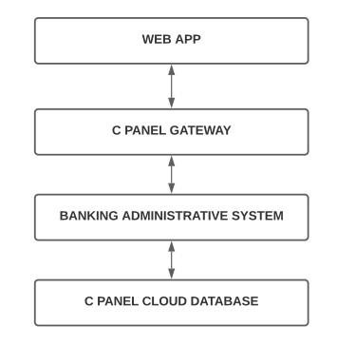

* + - 1. **High Level Architecture**

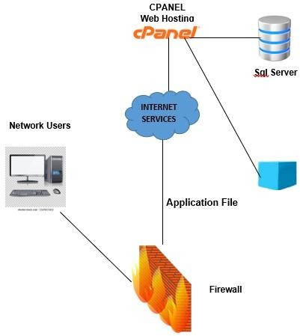

* + - 1. **Process Flow**

**Admin Flow**

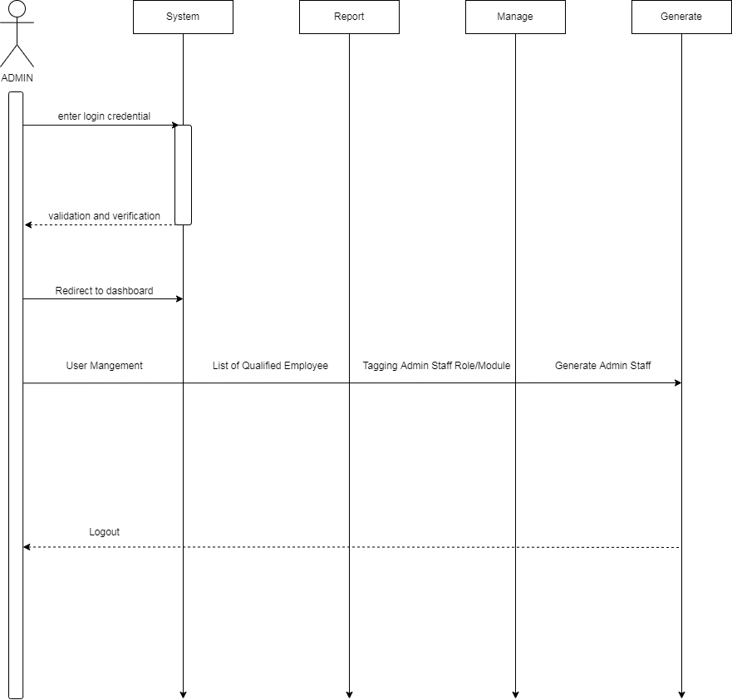

**Legal Management Flow**

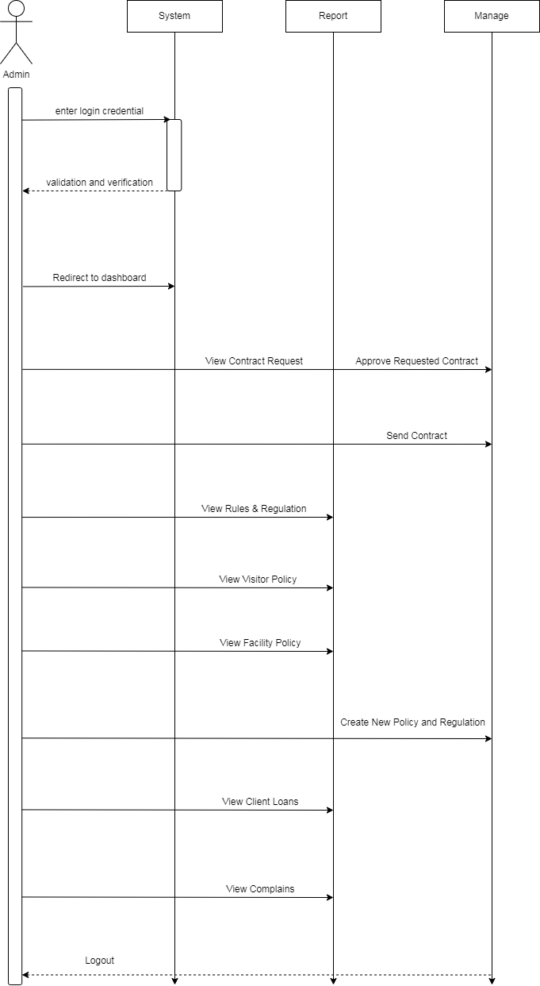

**Admin Staff Legal Management Flow**

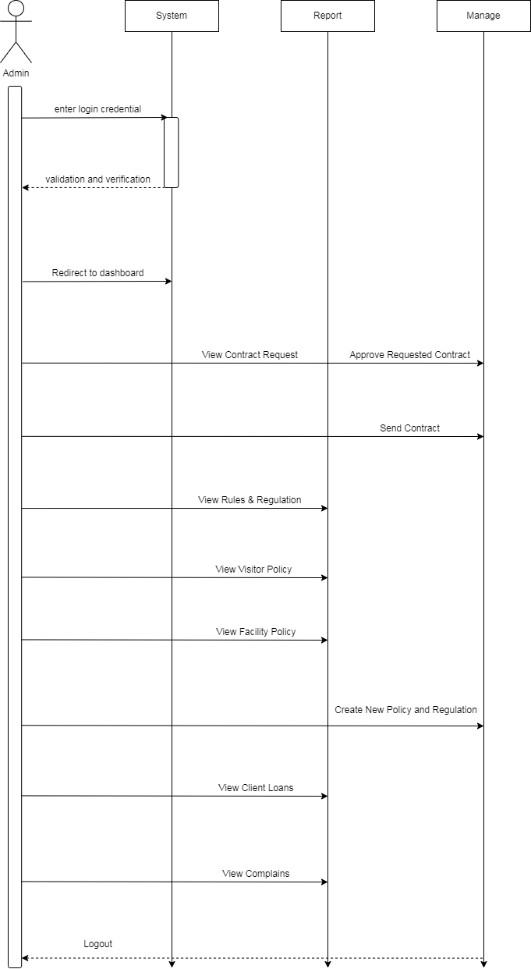

**Document Management Flow**

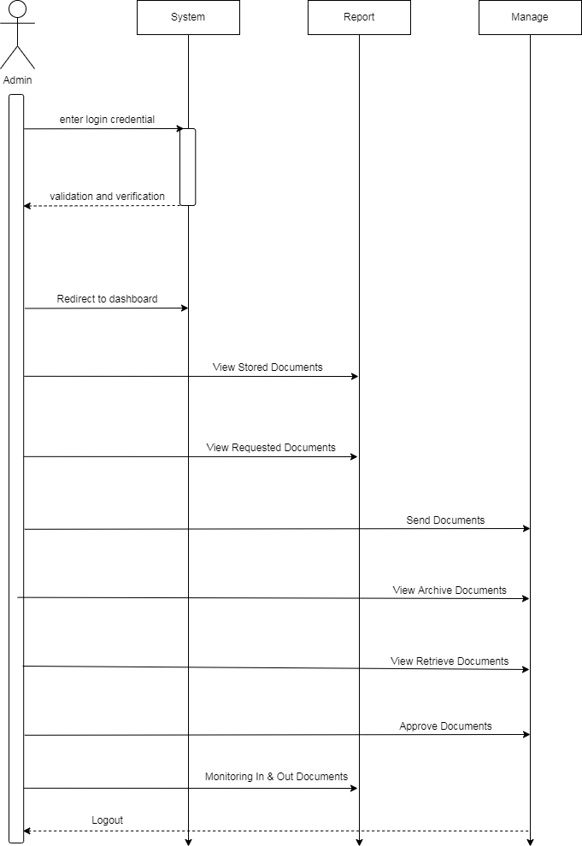

**Admin Staff Document Management Flow**

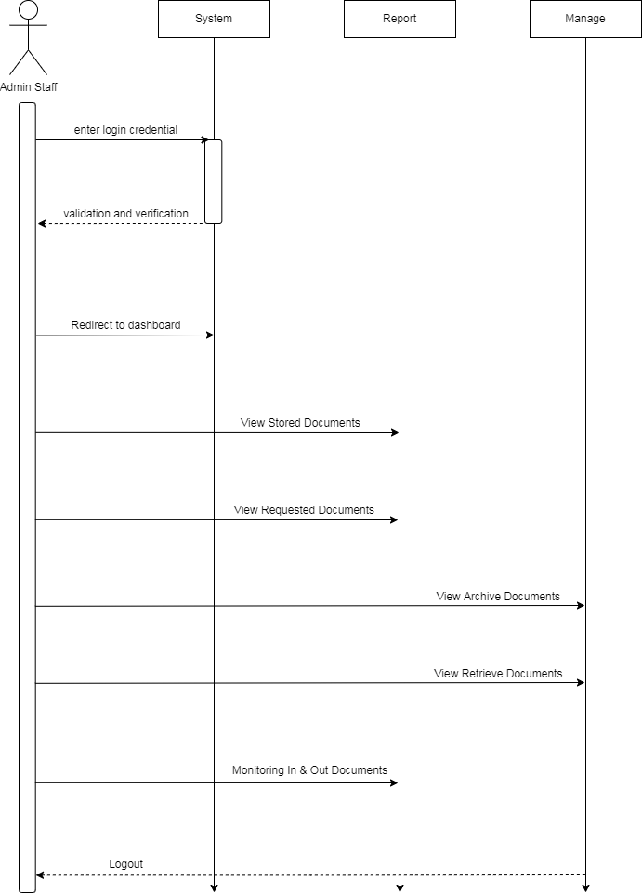

**Visitor Management**

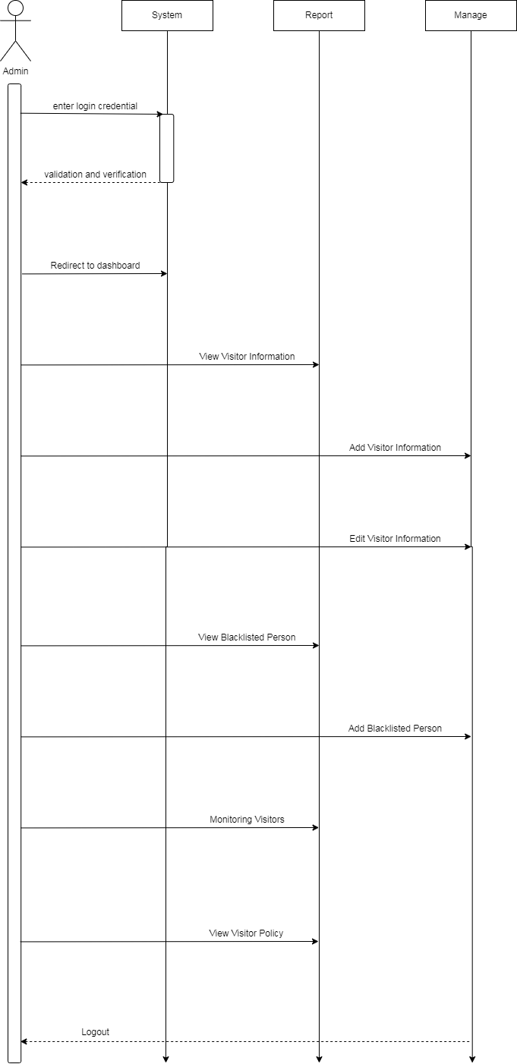

**Admin Staff Visitor Management**

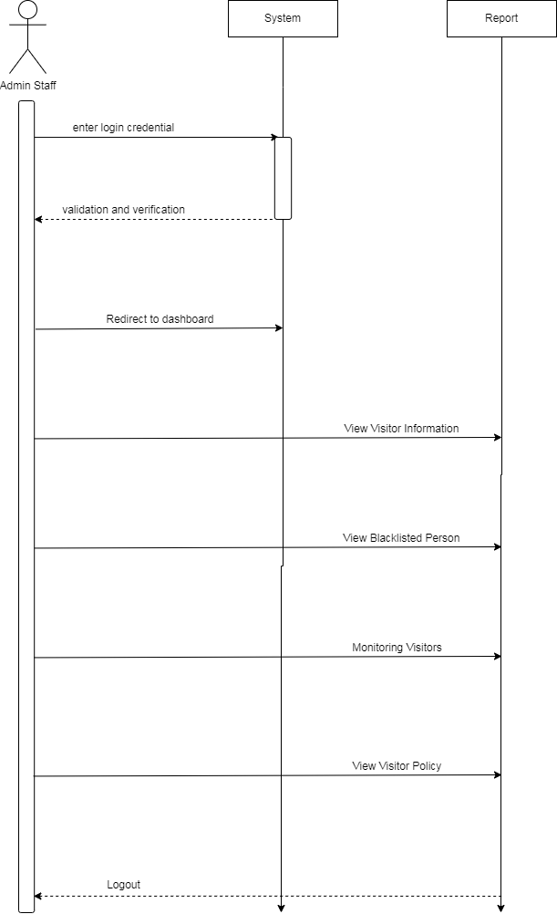

* + 1. **Implementation Timeline**

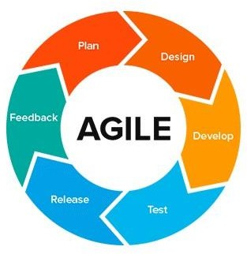

**Planning:**

Once an idea is deemed viable and feasible, the project team comes together and works to identify features. The goal of this phase is to break down the idea into smaller pieces of work (the features) then to prioritize each feature and assign it to iteration.

# Design:

The system and software design are prepared from the requirements identified in the previous phase. The team needs to think about what the product or solution will look like. The test team also comes up with a test strategy or plan to proceed.

# Implementation, coding or development:

This phase is all about creating and testing features, and scheduling iterations for deployment (following the iterative and incremental development approach [IID]). The development phase starts with iteration 0, because there are no features being delivered. This iteration lays down the foundation for development, with tasks like finalizing contracts, preparing the environments, and funding.

# Testing

Once the code has been developed, it is tested against the requirements to make sure the product is actually solving customer needs and matching user stories. During this phase, unit testing, integration testing, system testing, and acceptance testing are done.

# System architecture

* + 1. **Business Process Architecture**

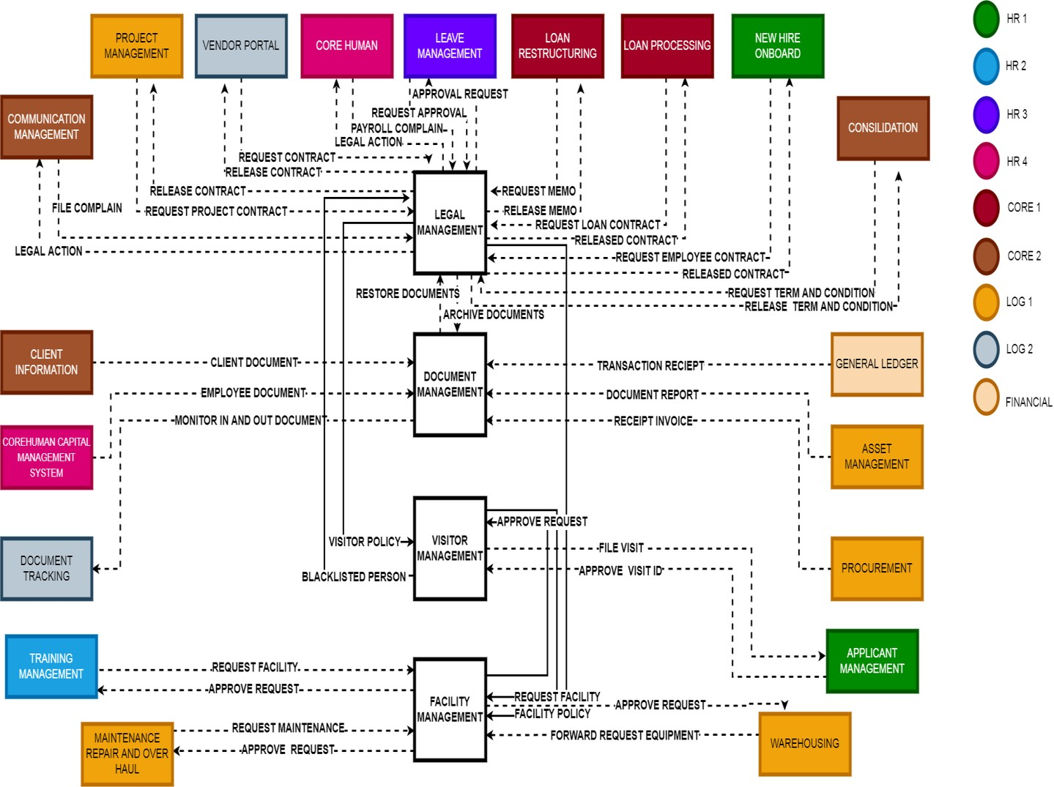

* + 1. **Application Architecture**

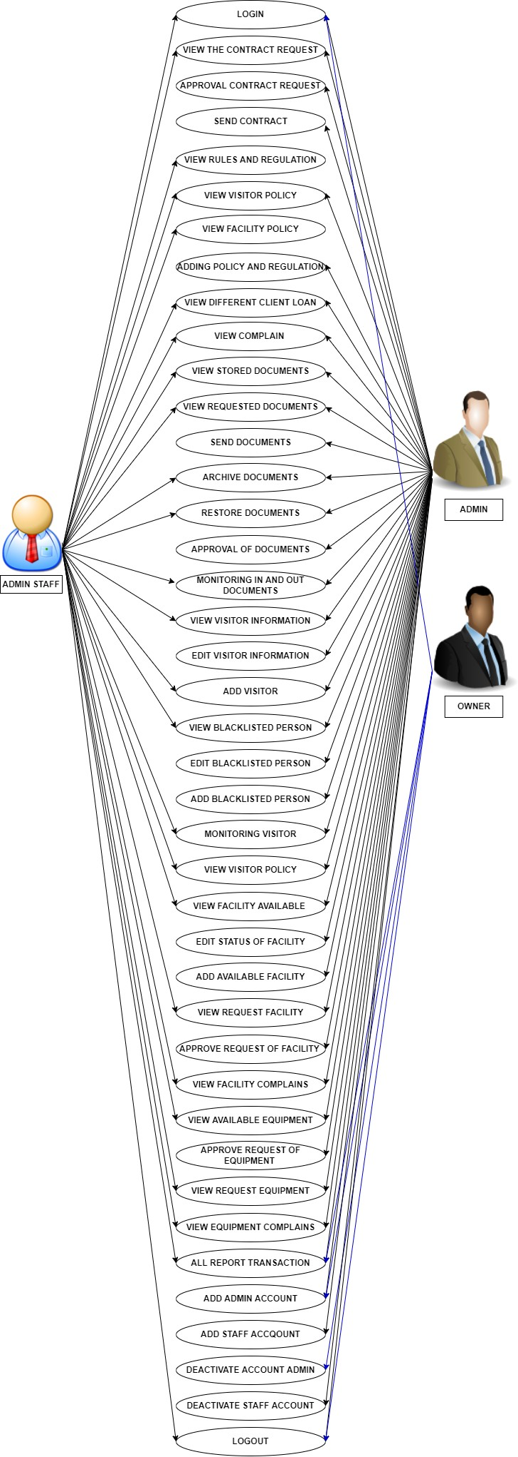

**Legal Management**

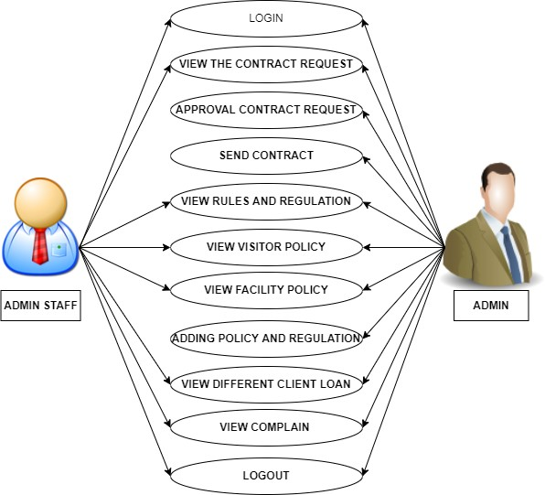

**Document Management**

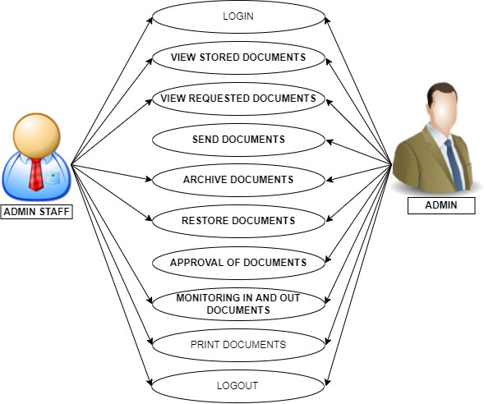

**Visitor Management**

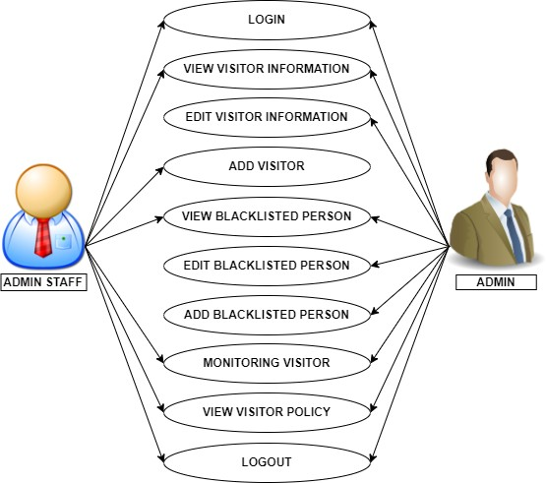

**Facility Management**

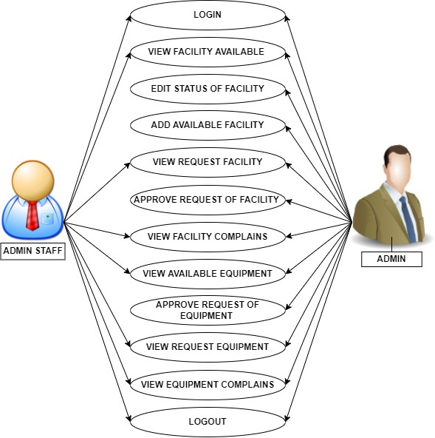

* + 1. **Data Architecture Legal Management**

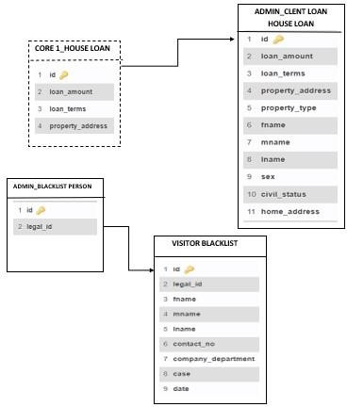

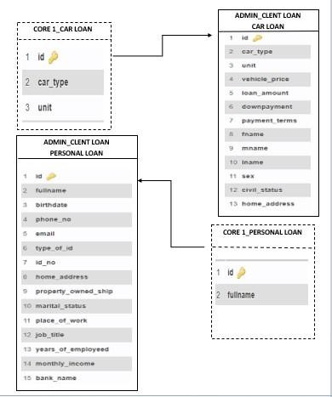

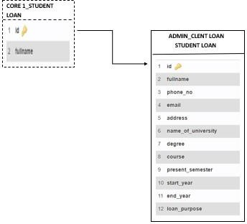

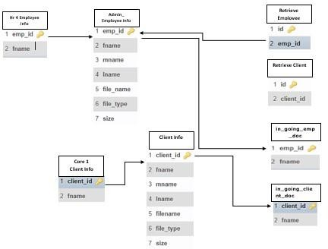**Document Management**

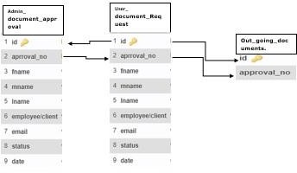**Management**

**Facility Management**

**Visitor**

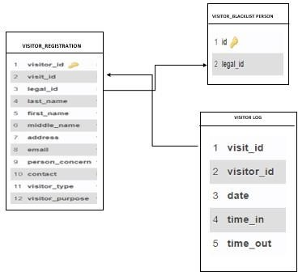

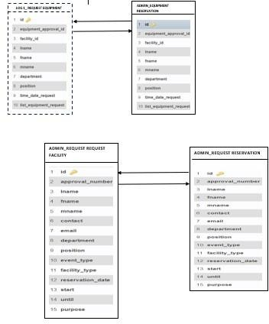

* + 1. **Technology Architecture**

|  |  |  |
| --- | --- | --- |
| **Logo and Icons** | **Description** | |
| **Software** | | |
|  | Database MSSQL | Before publishing a website or client to the main server, XAMPP allows a local host or server to test it on computers  and laptops. |
|  | Html | HTML stands for complete hypertext markup language, and it is a formatting method for displaying information acquired  from the Internet. A Web page |

|  |  |  |
| --- | --- | --- |
|  |  | (from the World Wide Web) is a retrieval unit that frequently contains hypertext links that allow similar pages to be  accessed. |
|  | Css | The term "Cascading Style Sheets" is an abbreviation for "Cascading Style Sheets." CSS (Cascading Style Sheets) is a computer language for designing and organizing web pages (HTML or XML). This language is made up of "cascading style sheets," sometimes known as CSS files, and it comprises coding  elements. |
|  | Php | This language is use for making the system. |
| **Hardware** | | |
|  | Work Station | This is use for the creation and platform of the system. |

***Table 29. Technology Architecture***

1. **Product Backlog**
   1. **Product backlog (user stories) Table**

|  |  |  |  |  |  |
| --- | --- | --- | --- | --- | --- |
| **User Story Number** | **User Stories** | **User Story Priority** | **Requireme nts Reference**  **s** | **Revise Status Priority** | |
| **LEGAL MANAGEMENT** | | | | | |
| 1 | As an admin user, I want to view all the clients complains so that I can provide legal attention/ action | 1 |  |  |  |
| 2 | As an admin user, I want to view all the list of requests of contract in  one display. |  |  |  |  |

|  |  |  |  |  |  |
| --- | --- | --- | --- | --- | --- |
| 3 | As an admin user, I want to view the different contracts that has been  sent to the department. |  |  |  |  |
| 4 | As an admin user, I want to view the rules and regulation of the bank. |  |  |  |  |

|  |  |  |  |  |  |
| --- | --- | --- | --- | --- | --- |
| 5 | As an admin user, I want to insert new rules and regulation of the bank. |  |  |  |  |
| 6 | As an admin user, I want to edit the rules and regulation of the bank for the new update given by  the head. |  |  |  |  |
| 5 | As an admin user, I want to view all the blacklisted person. |  |  |  |  |
| 6 | As an admin user, I want to view the different types of client’s loans. |  |  |  |  |
| 8 | As an admin user, I want to view the information of the client who loan. |  |  |  |  |
| 9 | As an admin user, I want to search the specific name of the complainant  and clients. |  |  |  |  |
| 10 | As an admin user, I want to convert the data from the table into .csv and .pdf  format |  |  |  |  |

|  |  |  |  |  |  |
| --- | --- | --- | --- | --- | --- |
| **DOCUMENT MANAGEMENT** | | | | | |
| 13 | As an admin user, I want to view the employee’s documents |  |  |  |  |
| 14 | As an admin user, I want to view the client  documents |  |  |  |  |
|  | As an admin user, I want to view the receipt of  payroll |  |  |  |  |
| 15 | As an admin user, I want to view the receipt of  financial |  |  |  |  |
|  | As an admin user I want to view the request of documents from the  different departments |  |  |  |  |
| 16 | As an admin user, I want to approved the document request. |  |  |  |  |
| 17 | As an admin user, I want to archive all legal documents years from 3-5  years old. |  |  |  |  |

|  |  |  |  |  |  |
| --- | --- | --- | --- | --- | --- |
| 18 | As an admin user, I want to view the in and out going documents |  |  |  |  |
|  | As an admin user, I want to view the archive of all receipts |  |  |  |  |
| 19 | As an admin user, I want to view the archive documents of employees  and clients |  |  |  |  |

|  |  |  |  |  |  |
| --- | --- | --- | --- | --- | --- |
| **VISITOR MANAGEMENT** | | | | | |
| 20 | As an admin user I want to search the specific information of the visitor |  |  |  |  |
| 21 | As an admin user, I want to view the information of the specific visitor |  |  |  |  |
| 22 | As an admin user, I want  to view the total number of visitors |  |  |  |  |
| 23 | As an admin user, I want to generate visitor reports |  |  |  |  |
| 24 | As an admin user I want  to have a log in form for monitoring purposes |  |  |  |  |

|  |  |  |  |  |  |
| --- | --- | --- | --- | --- | --- |
| 25 | As an admin user I want to view the blacklisted  person |  |  |  |  |
| **FACILITY MANAGEMENT** | | | | | |
| 26 | As an admin user, I want to view the request for the facility reservation | 26 |  |  |  |
| 27 | As an admin user, I want to view the request maintenance for  the facility | 27 |  |  |  |
| 28 | As an admin user, I want to approved all the request | 28 |  |  |  |
| 29 | As an admin user, I want to generate report of  facility and equipment | 29 |  |  |  |
| 30 | As an admin user, I want to view the facility  complains | 30 |  |  |  |
| 31 | As an admin user, I want to view the available date and time of facility and  equipment | 31 |  |  |  |

***Table 30. Product backlog (user stories) Table***

* 1. **Product Backlog for EIS Information Security**

|  |  |  |  |  |
| --- | --- | --- | --- | --- |
| **User User Stories Story**  **Number** | | **User Stories Priority** | **Revised Status Priority** | |
| 1 | As a developer, I want to create a login form that encrypt the password and convert it into a  hashed |  |  |  |
| 2 | As a developer, I want to create a restriction that limit the user functionalities depending on their role |  |  |  |
| 3 | As a developer, I want to create a restriction that every 3- consecutive error in log-in it will terminate the accessibility |  |  |  |
| 4 | As a developer, I want to create table that records every log history of user and their IP  address |  |  |  |
| 5 | As a developer, I want to restrict SQL injection by preventing the use of more secured condition statements |  |  |  |
| 6 | As a developer, I want to monitor every transaction done in the  system |  |  |  |

***Table 31. Product Backlog for EIS Information Security***

* 1. **Product Backlog for EIS Standards**

|  |  |  |  |  |  |
| --- | --- | --- | --- | --- | --- |
| **EIS**  **Standards Number** | **EIS Standards Stories** | **EIS**  **Standards Priorities** | **Requirements Reference** | **Revised Priority** | **Status** |
| 1 | As a developer,  I want to see all |  |  |  |  |

|  |  |  |  |  |  |
| --- | --- | --- | --- | --- | --- |
|  | input controls to know if the sizes are all the  same |  |  |  |  |
| 2 | As a developer, I want the system to be presentable to  the eye |  |  |  |  |
| 3 | Have a server type system so that the team can easily manage all the accounts that accessed in the  system |  |  |  |  |
| 4 | Used MSSQL  as a database  for the whole system |  |  |  |  |

|  |  |  |  |  |  |
| --- | --- | --- | --- | --- | --- |
| 5 | As a team developer we used html, php for the coding of  the system |  |  |  |  |
| 6 | As a team developer, we used css,  bootstrap for |  |  |  |  |
|  | the design of the  system |  |  |  |  |

***Table 32. Product Backlog for EIS Standards***



* + 1. **UI/UX (Icons, color, etc.)**

|  |  |  |  |  |  |
| --- | --- | --- | --- | --- | --- |
| **Standards Standards Standards Requirement’s Revision Status Number Description Priorities Reference Priority** | | | | | |
| **1** | As a developer, I want to have a grey, white, blue  and sky-blue color combination  . | 1 |  |  |  |

|  |  |  |  |  |  |
| --- | --- | --- | --- | --- | --- |
|  |  |  |  |  |  |
| **2** | As a developer, I want to have a login form. | 2 |  |  |  |

|  |  |  |  |  |  |
| --- | --- | --- | --- | --- | --- |
| **3** | As a developer, I choose a logo for the legal  management system | 3 |  |  |  |

|  |  |  |  |  |  |
| --- | --- | --- | --- | --- | --- |
| **4.** | As a developer, I choose a logo for the  Document management system | 4 |  |  |  |
| **5** | As a developer, I choose a logo for the Visitor  management system | 5 |  |  |  |
| **6** | As a developer, I choose a logo for the Facility  management system | 6 |  |  |  |
| **7** | As a developer, I want the button color to be blue so that the color is uniform | 7 |  |  |  |
| **8** | As a developer I want to have a profile picture. | 8 |  |  |  |



***Table 33. UI/UX (Icons, color, etc.)***

**Messages**

|  |  |  |  |  |  |
| --- | --- | --- | --- | --- | --- |
| **Messages**  **Number** | **Messages Messages**  **Stories Priorities** | | **Requirements Revised references Priority** | | **Status** |
| **1** | Password were not filled | **1** |  |  |  |
| **2** | As administrative staff, I must not log in when the user’s name and password is incorrect | **2** |  |  |  |
| **3** | As administrative staff, I must be able to request a password  reset if I forgot my password | **3** |  |  |  |

**Database**

|  |  |  |  |  |
| --- | --- | --- | --- | --- |
| **No.** | **EIS Database**  **Stories** | **EIS Database**  **Priorities** | **Revised**  **Priority** | **Status** |
| **1** | As an admin, I want the naming convention of the database to be easy to  understand | **1** |  |  |
| **2** | As an admin, I want to have a consistent naming of table  attributes | **2** |  |  |
| **3** | As an admin, I want the database to have consistent  key relationships | **3** |  |  |
| **4** | As an admin, I want to have a consistent naming of data  tables | **4** |  |  |

* 1. **Product Backlog for integration**

|  |  |  |  |  |  |
| --- | --- | --- | --- | --- | --- |
| **Standards**  **Number Description** | | **Standards Requirement’s Revision Status Priorities Reference Priority** | | | |
| **1** | As an admin, I want to connect to Human Resource 1 to provide contract for the newly  hired employee | 1 |  |  |  |
| **2** | As an admin, I want to connect to logistics 2 for supplier’s  contract | 2 |  |  |  |

|  |  |  |  |  |  |
| --- | --- | --- | --- | --- | --- |
| **3** | As an admin, I want to connect to Logistic 1 to approve the request from warehousing | 3 |  |  |  |

|  |  |  |  |  |  |
| --- | --- | --- | --- | --- | --- |
| **4** | As an admin, I want to connect to Core Human 1 so that I can provide the client’s contract and memo letter  they needed | 4 |  |  |  |
| 5 | View all complaints | 5 |  |  |  |
| **6** | As an admin, I want to connect to Core II for account consolidation | 6 |  |  |  |

***Table 34. Product Backlog for integration***

* 1. **Product Backlog for analytics**
     1. **Application System Analytics**

|  |  |  |  |  |
| --- | --- | --- | --- | --- |
| **User**  **Story Number** | **User Stories** | **User**  **Stories Priorities** | **Requirement’s Revised Reference Priority** | **Status** |

|  |  |  |  |  |  |
| --- | --- | --- | --- | --- | --- |
| **1** | Have  analytical report of all the visitors  daily | 1 |  |  |  |
| **2** | Have  analytical report of total number of reservation of facilities that were occupied  daily | 2 |  |  |  |
| **3** | Have an  analytical report of complaints that resolves  daily | 3 |  |  |  |
| **4** | Have an  analytical report of transaction about ingoing and outgoing documents that monitored | 4 |  |  |  |

***Table 35. Application System Analytics***

* + 1. **EIS Analytics**

|  |  |  |
| --- | --- | --- |
| **User ID** | **User Story** | **Priority** |
| 1 | As a Product owner, I must be able to view a live data count in the EIS main dashboard that allows user to see constant changes of data.  ◄ Create a dashboard raw count |  |
| 2 | As a Product owner, I must be able to view a pie chart which |  |
| 3 | provides performance of every employee in each department.  ◄ Create an employee pie  chart |  |
| 4 | As a Product owner, I must be able to view a bar graph that indicate a level of all employee that has been hired to the company so that it can easily identify if its increasing or decreasing.  ◄ Create a new hire bar graph |  |

***Table 36. EIS Analytics***

* 1. **backlog table**

**Sprint**

* + 1. **User stories**

|  |  |  |  |  |  |
| --- | --- | --- | --- | --- | --- |
| **User Story**  **Number** | **User Stories Tasks (1…n) User Story**  **Points** | | | **Responsibility Team**  **Members** | |
| **LEGAL MANAGEMENT** | | | | | |
| 1 | As a developer, I want to create a table to view the list of client complaints | 1. Create a table for list of client complaints 2. Add a search bar to filter the monitoring 3. Coding the viewing of client’s complaint 4. Testing a table of client’s complaint |  | | Amatos, Jean Rose Parael, Shalomae |

|  |  |  |  |  |
| --- | --- | --- | --- | --- |
| 2 | As a developer, I want to create a table that can view the request from the different departments | 1. Design a different button for each department 2. Create a table for request of department 3. Coding the viewing if request 4. Testing the table of request per department |  | Amatos, Jean Rose Parael, Shalomae |

|  |  |  |  |  |
| --- | --- | --- | --- | --- |
| 3 | As a developer, I want to create uploading form of different contracts to release/send to the specific  departments | 1. Design a form of uploading file 2. Coding the function of uploading form 3. Testing the   function of upload files |  | Amatos, Jean Rose Parael, Shalomae |
| 4 | As a developer, I want to create a table that can view all the different contracts that has been sent | 1. Create a button for different department 2. Create table for view the contract per department 3. Coding the function of table in per department 4. Testing the table |  | Amatos, Jean Rose Parael, Shalomae |
| 5 | As a developer, I want to create a table form that can view the rules and regulation of the bank | 1. Create a table of rules and regulation 2. Create a function for table of rules and regulation 3. Testing the   table |  | Amatos, Jean Rose Parael, Shalomae |

|  |  |  |  |  |
| --- | --- | --- | --- | --- |
| 6 | As a developer, I want to create a table to view the different blacklisted person | 1. Create a table of blacklisted person 2. Create a function for table of blacklisted person 3.Testing the table |  | Amatos, Jean Rose  Parael, Shalomae |
| 7 | As a developer, I want to create a table by category so that it can be orgnized | 1. Create a different table of client loans 2. Create a function for all different tables 3. Testing the table |  | Amatos, Jean Rose  Parael, Shalomae |
| 8 | As a developer, I want to create a form that is editable so that it can insert the client’s information for the releasing of contracts |  |  | Amatos, Jean Rose  Parael, Shalomae |
| 9 | As a developer, I want to create a search bar to view the specific  information | 1. Create a search bar 2. Create a function for search bar |  | Amatos, Jean Rose  Parael, Shalomae |

|  |  |  |  |  |
| --- | --- | --- | --- | --- |
|  |  | to allocate the information client loans  3. Testing the  search bar |  |  |
| 10 | As a developer, I | 1. Create to button |  | Amatos, Jean |
|  | want to create an | of excel, pdf etc. | Rose |
|  | excel and pdf form | 2. Create function | Parael, |
|  |  | for transfer the data | Shalomae |
|  |  | into another form |  |
|  |  | 3. Testing the |  |
|  |  | button |  |

|  |  |  |  |  |
| --- | --- | --- | --- | --- |
| **DOCUMENT MANAGEMENT** | | | | |
| 11 | As a developer, I want to create a table for the employee documents | 1. Create a table to view the employee documents 2. Create a function for table of employee documents 3. Testing the   table |  | Gabule, Dexter |

|  |  |  |  |  |
| --- | --- | --- | --- | --- |
| 12 | As a developer, I want to create a table for the client’s documents | 1. Create a table to view the client documents 2. Create a function for table of client’s document 3. Testing the   table |  | Gabule, Dexter |
| 13 | As a developer, I want to create a table to view the request of documents from the different department | 1. Create a different table to view the document request 2. Create a function for table of employee documents 3. Testing the   table |  | Gabule, Dexter |
| 14 | As a developer, I want to create a table to view the request receipt of payroll | 1. Create a table for receipt of payroll as a copy 2. Create a function for table of receipt of payroll 3. Testing the   table |  | Gabule, Dexter |
| 15 | As a developer, I want to create a table to view the request receipt of  financials | 1. Create a table for receipt of financial as a copy |  | Gabule, Dexter |

|  |  |  |  |  |
| --- | --- | --- | --- | --- |
|  |  | 1. Create a function for table of receipt of financial 2. Testing the table |  |  |
| 16 | As a developer, I want to create a table that can approved all the request | 1. Create a button for approval 2. Create a function of approval the request 3. Testing the approval button |  | Gabule, Dexter |

|  |  |  |  |  |
| --- | --- | --- | --- | --- |
| 17 | As a developer, I want to create a table that automatic store all the legal documents | 1. Create the archiving documents table 2. Create a function for archiving table 3. Testing the   table |  | Gabule, Dexter |

|  |  |  |  |  |
| --- | --- | --- | --- | --- |
| 18 | As a developer, I want to create a table to view the in and out going documents | 1. Create a table for in going documents 2. Create a table for outgoing documents 3. Create a function for table of in and out going documents 4. Testing the   table |  | Gabule, Dexter |
| 19 | As a developer, I want to create another table for archiving the employee and client’s documents | 1. Create a table for archive client documents 2. Create a table for archive employee documents 3. Create a function for table of archive employee and client’s documents 4. Testing the   table |  | Gabule, Dexter |
| 20 | As a developer, I want to create another table for archiving the receipts | Create a table for archive all receipts   1. Create a function for table of archiving all receipt 2. Testing the   table |  | Gabule, Dexter |

|  |  |  |  |  |
| --- | --- | --- | --- | --- |
| **VISITOR MANAGEMENT** | | | | |
| 21 | As a developer, | 1. Create a table |  | Partosa, Vhon |
|  | I want to create | for information of |  |
|  | a table in order | visitor |  |
|  | to view all the | 2. Create a |  |
|  | information of | function for table of |  |
|  | visitors | visitor information |  |
|  |  | 3. Testing the |  |
|  |  | table |  |
| 22 | As a developer, | 1. Create a |  | Partosa, Vhon |
|  | I want to create | search bar |  |
|  | a search bar to | 2. Create a |  |
|  | view the | function for search bar |  |
|  | specific | to allocate the |  |
|  | information of | information of visitor |  |
|  | visitors | 3. Testing the |  |
|  |  | search bar |  |
|  |  | 4. |  |

|  |  |  |  |  |
| --- | --- | --- | --- | --- |
| 23 | As a developer, I want to create a login form for visitor monitoring purposes | 1. Create a login form for visitor 2. Create a function login form to allocate the in and out 3. Testing the log in form |  | Partosa, Vhon |
| 24 | As a developer, I want to create a table to generate visitor report | 1. Create a table for all reports of visitor information 2. Create a function of table 3. Testing the   table |  | Partosa, Vhon |
| **FACILITY MANAGEMENT** | | | | |
| 25 | As a developer, I want to create a table to view the request reservation | 1. Create a table for all facility request 2. Create a function of facility request table 3. Testing the table |  | Dela Cruz, Kimberly |

|  |  |  |  |  |
| --- | --- | --- | --- | --- |
| 26 | As a developer, I want to create a table to view the request maintenance for the facility | 1. Create a table for maintenance request of facility 2. Create a function of maintenance table request 3. Testing the table |  | Dela Cruz, Kimberly |
| 27 | As a developer, I want to create approval for all the request | 1. Create the approval button for request facility 2. Create function for approve the request 3. Testing the   approval button |  | Dela Cruz, Kimberly |
| 28 | As a developer, I want to create a table to view the facility available | 1. Create a table to view the facility available 2. Create function of table the available facility 3. Testing the table |  | Dela Cruz, Kimberly |
| 29 | As a developer, I want to create a table to view | 1. Create a table to view the equipment available |  | Dela Cruz, Kimberly |

|  |  |  |  |  |
| --- | --- | --- | --- | --- |
|  | the equipment available | 1. Create function of table the available equipment 2. Testing the table |  |  |
| 30 | As a developer, I want to create a table to view the generate reports of facility and equipment’s | 1. Create a table to view all the report of facility available and equipment 2. Create function of table 3. Testing the   table |  | Dela Cruz, Kimberly |

***Table 37. Sprint backlog table User stories***

* + 1. **Information security**

|  |  |  |  |  |
| --- | --- | --- | --- | --- |
| **IS Number** | **IS Description** | **Tasks (1…n)** | **IS Points** | **Responsible Team members** |
| 1 | Must have Login password encryption user’s security and avoid unauthorized  access | Create a login form with better security |  |  |
| 2 | Restriction for limitation of user | Create a  restriction limit |  |  |
|  | access and protects  necessary data. |  |  |  |

|  |  |  |  |  |
| --- | --- | --- | --- | --- |
| 3 | Login attempt to avoid access trying  entries | Create a login attempt |  |  |

***Table 38. Sprint backlog Information security***

* + 1. **EIS standard**

|  |  |  |  |  |
| --- | --- | --- | --- | --- |
| Standard Number | Standard Description | Tasks (1…n) | IS  Standard Points | Responsible Team members |
| 1 | Create User | Designing |  |  |
|  | Interface and also | system and |
|  | based on the | website user |
|  | standard system | interface for each |
|  | template | module |
| 2 | Set standard icons | Inserting |  |  |
|  | and contents such | standard icons |
|  | as text for design | Settings of |
|  | uniformity | appropriate font |
|  |  | size and colors. |
| 3 | The system should display a confirmation dialog before client could continue | Adding confirmation dialog box function for a  specific feature. |  |  |
|  |  | Testing |
| 4 | The system should display an error  message if the user | Adding error message dialog  box for a try and |  |  |

|  |  |  |  |  |
| --- | --- | --- | --- | --- |
|  | has invalid inputs or  has unauthorized access. | catch and other features.  Testing |  |  |
| 5 | The system should display a message containing instructions for valid data inputs | Adding functions for yes or no dialog box, or  containing guidelines testing |  |  |
| 6 | The data should be normalized to avoid data anomalies and redundancy | Creating database schema for data normalization.  Inputting and  integrating data testing |  |  |
| 7 | Should have a recovery and back up features in case of risk such as data  loss | Create a backup database |  |  |
| 8 | The database should be secured to prevent unauthorized access of data. | Setting permission and for specified database users.  Requiring  password for access entry |  |  |

***Table 39. Sprint backlog EIS standard***

* + 1. **EIS integration**

|  |  |  |  |  |  |
| --- | --- | --- | --- | --- | --- |
| Integration Number | Integration Description | Tasks (1…n) | | Integration Points | Responsible  Team members |
| 1 | The system can send and view data inputs, changes and updates | Create  integrated  data connection | an |  |  |
| 2 | The EIS is integrated to the system and can send and receive updates in real time | Create  integrated data  connection | an |  |  |

***Table 40. Sprint backlog EIS integration***

* + 1. **Analytics**

|  |  |  |  |  |
| --- | --- | --- | --- | --- |
| Analytics Number | Analytics Tasks (1…n) Description | | Analytics Points | Responsible  Team members |
| 1 | Administrative analytics must have the total number of visitors, total number of contracts and  complaints | Create Dashboards |  |  |

***Table 41. Sprint backlog Analytics***

* 1. **Sprint Burndown Chart**
     1. **Sprint Backlog**

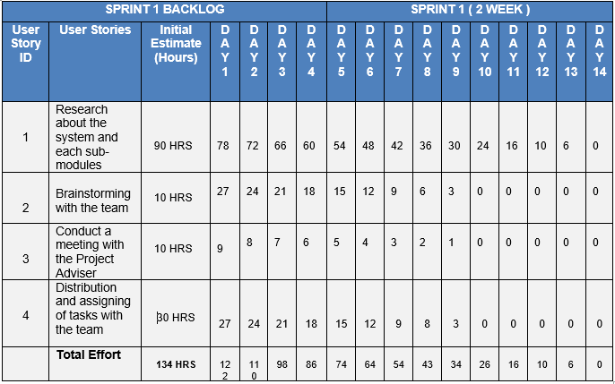

180

160

140

120

100

80

60

Series 1

Series 2

Series 3

40

20

0

Day Day Day Day Day Day Day Day Day Day Day Day Day Day

1 2 3 4 5 6 7 8 9 10 11 12 13 14

* Initial Estimate
* Research about assigning modules for each member.
* Brainstorming with a team.
* Conduct a meeting with the Adviser.
* Planning and assigning tasks with a team.

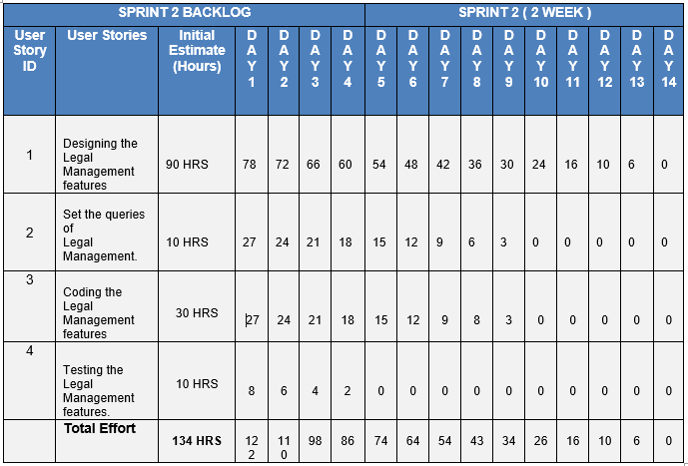

250

200

150

Series 1

100

Series 2

Series 3

50

0

Day Day Day Day Day Day Day Day Day Day Day Day Day Day

1 2 3 4 5 6 7 8 9 10 11 12 13 14

* Designing the Legal Management features.
* Set the queries of the Legal Management system
* Coding Legal Management system
* Testing the Legal Management system features

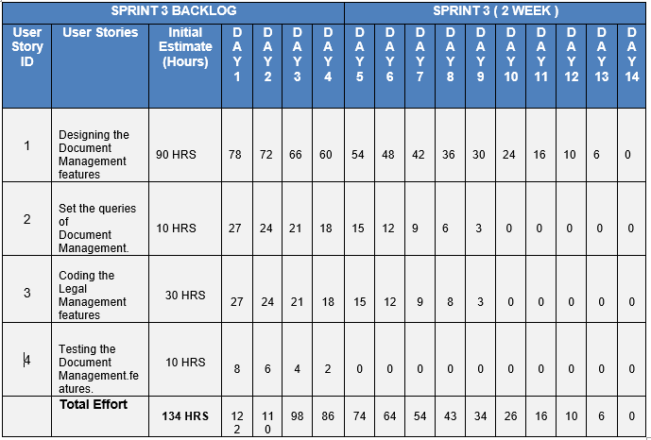

180

160

140

120

100 Series 1

80 ~~Ser~~ies 2

60 ~~Ser~~ies 3 40

20

0

Day 1Day 2Day 3Day 4Day 5Day 6Day 7Day 8Day 9Day 1D0ay 1D1ay 1D2ay 1D3ay 14

- Initial Estimate

* Designing the Document Management features.
* Set the queries of the Document Management system
* Coding Document Management system
* Testing the Document Management system features

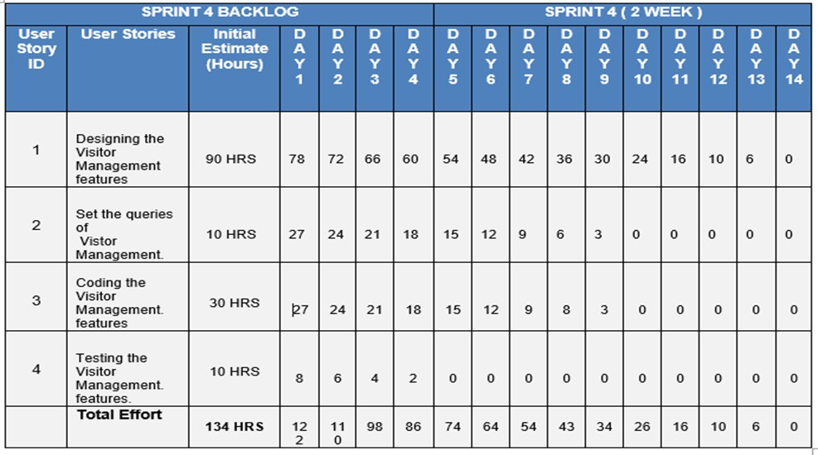

-

180

160

140

120

100

80

60

Series 1

Series 2

Series 3

40

20

0

Day 1 Day 2 Day 3 Day 4 Day 5 Day 6 Day 7 Day 8 Day 9Day 10Day 11Day 12Day 13Day 14

* Initial Estimate
* Designing the Visitor Management features.
* Set the queries of the Visitor Management system
* Coding Visitor Management system
* Testing the Visitor Management system features

# Information and Data Management

* + 1. **Data Integration Model Legal Management**

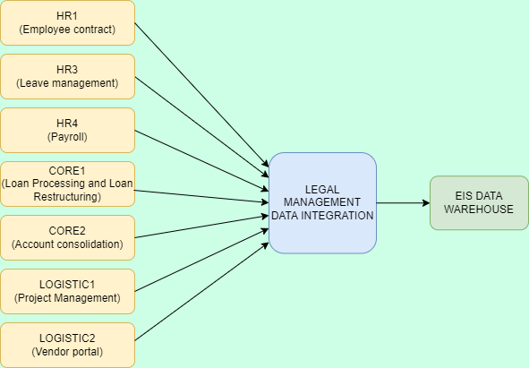

This model explains the Legal Management process of how the data integrated from different data sources applications and store all the data collected to Eis warehouse.

# Document Management

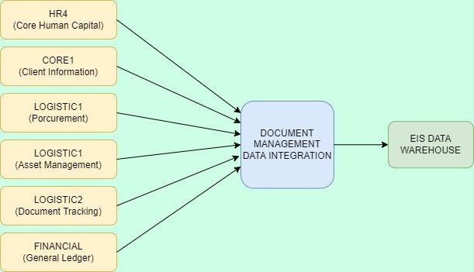

This model explains the Document Management process of how the data integrated from different data source applications and store all the data collected to Eis warehouse.

# Visitor Management

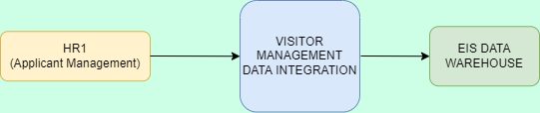

This model explains the Visitor Management process of how the data integrated from different data source applications and store all the data collected to Eis warehouse.

# Facility Management

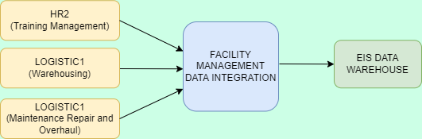

This model explains the Facility Management process of how the data integrated from different data source applications and store all the data collected to Eis warehouse.

# Data Migration Strategies

The Trickle Migration approach is used phased approach to data migration. This strategy is fairly useful specially in agile methodology because it breaks down the migration process into sub- processes where data is transferred in small increments. During the implementation, the old system and the new are run in parallel, which eliminates downtown or opertional interruptions. Processes running in real- time can keep data continuously migrating.

However, on the drawback, the iterative nature of the process makes it more convulated and it takes longer to complete. During the whole process, data should be synchronized between the old system and the new environment.

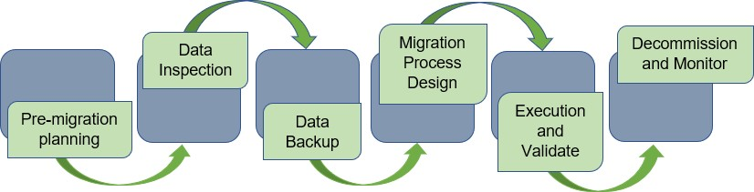

# Pre-migration planning

The planning involves the evaluation of existing data sets for stability. The team evaluate first the scope of data to be migrated. We have compiled the typical scope options of data involved in the Data migration process. These include the data from department information like charts of accounts, employees, clients and contracts. The data also includes information from the customers complains and storing of documents of clients and employee. Accounting data like general ledger, approve visit id, requesting of facility, approve request from the training management and approve maintenance request is also included in the data migration process.

# Data Inspection

The team collects all existing data from the existing database and loads that data into the Eis database to test data integrity and compatibility between the way maintenance data is collected and the new database.

# Data Backup

The team created and stored copies of data to cloud to protect if ever they encounter any problems during migration such as corrupt, incomplete or missing files. It provides virtual data storage and quick access to your materials from any location, not only a local computer or external hard disk.

# Migration Process Design

Assigning the project teams, in particular the developers and system analysts, are constantly working to avoid any problems from occurring and to place them in their proper positions when the migration is taking place.

# Execution and Validate

Users can either import data from their old banking system using PhpMyAdmin or manually encode data in the new system. In order to refine when each sub-migration is to be sent out and to which group of users, the migration team needs connect with business units.

# Decommission and Monitor

Once the migration is complete, the team ensure there are no connectivity problems with source and target systems. The goal is to ensure all data migrated is correct, secure, and in the proper location. To verify this, conduct unit, system, volume, web-based application and batch application test.

# Data Analytics (Business intelligence framework)

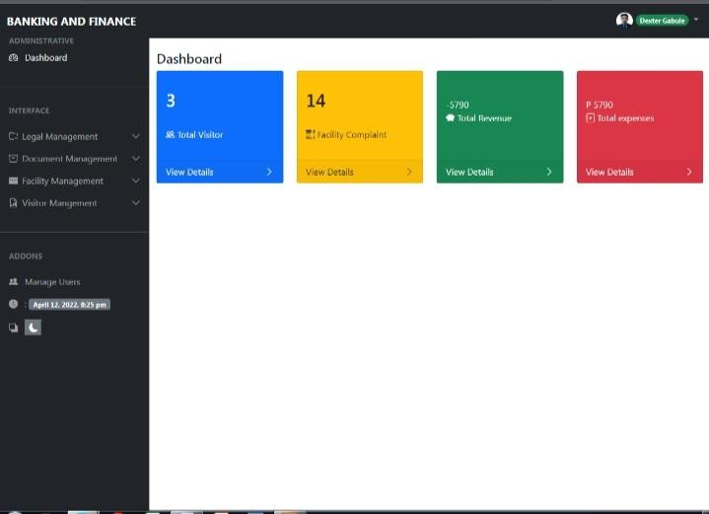

The dashboard of the system demonstrates the key values in the system like the total number of visitors, facilities complaints, documents, total revenues and expenses.

The main modules of the system are as follows: Legal Management, Document Management, Visitor Management and Facility Management. These modules are the main functionalities of the system.

# Privacy and Security

* All digital files are securely stored employing technical security to protect the confidential company information
* Only authorized individuals, such as developers and system analysts, have access to the system's back end.
* System users are restricted by their roles.
* The developing system has a security component that keeps track of when users log in and out of their accounts.

# Backup, Retention and Disposal

The data retention period specifies how long the organization can keep the data archived and stored. In general, the length of time depends on the type of data and how it is used.

|  |  |  |
| --- | --- | --- |
| **Data Category** | **Active Retention Period** | **Archived Retention Period** |
| Legal Documents (Different Contracts) | Till Business operated | 10 Years |
| Complaints Report | 3 Years | 3 Years |
| Clients loan Information | Till Business operated | 10 Years |
| Employee Documents | Till Employee is employed | 10 Years |
| Document (All) | 5 Years | 10 Years |
| Visitor Info | 3 Years | 5 Years |
| Visitors logs | 3 years | 5 years |
| Blacklisted Person | Till Employee is employed | 10 years |

|  |  |  |
| --- | --- | --- |
| Facility reports | Till Employee is employed | 10 years |

# INFORMATION SECURITY

* + 1. **APPLICATION SECURITY**

The developers developed security measures that apply in the system to prevent security vulnerabilities against threats such as unauthorized access or hackers.

|  |  |
| --- | --- |
| **SECURITY MEASURES** | **DESCRIPTION** |
| LOGIN FORM | The developers create a login form in order the user can access the system if they have already an account. They will have to input their username and password first before accessing the system. The purpose of login form is to ensure that only authorized user can access the system. |
| LOGIN ATTEMPT | The developers create a restriction that every 3- consecutive error in login it will terminate the accessibility. |
| STRONG PASSWORD | The developers apply a strong password that has a  sufficient length or 8 characters long, mix of special characters, numbers, uppercase and lowercase. |
| ENCRYPT PASSWORD IN DATABASE | The developers used a encrypt password to secure the database. It helps to protect private information and  sensitive data. |
| ACTIVITY LOGS/HISTORY LOGS | The developers create a table that records every history of user in order to monitor the users who login in the system. |

# INFRASTRUCTURE SECURITY

The developers apply different features of security in the system in order to secure the important information and sensitive data.

|  |  |
| --- | --- |
| **SECURITY MEASURES** | **DESCRIPTION** |

|  |  |
| --- | --- |
| BACKUP DATA | The developers create a backup data to have a copy of important data in the flash drive. |
| PASSWORD | The developers apply a strong password in the  computer to ensure that only authorized individual can access to the computer. |
| INSTALL ANTIVIRUS | The developers install an antivirus in the computer in order to protect from viruses. Antivirus has a big help to prevent any potential virus from infecting the computer. |

# CLOUD/WEB SECURITY

The developers create a security measures that help to secure the

clou/ web security.

* The developers apply user level access to the system in order to have a restriction which is users have a limitation on what information they can access and edit based on their role.
* In securing the internet the developers change the default name of the WIFI and the password for security purposes.
* The developers Install a firewall to control the internet coming and leaving traffic in a network.

# CRYPTOGRAPHY

The developers used encrypt data that is to ensure that all information will not access by unauthorized users because it will scramble the data into ciphertext to become unreadable to anyone without the correct password. The purpose of the developer to use encryption is to prevent unauthorized access or hackers.

# INCIDENT RESPONSE

The developers create a step-by-step response or action to prevent or mitigate the threats. The user can apply and follow the following steps.

# DATA BREACH

1. Disconnect from the internet by pulling the network cable from firewall to stop the bleeding of data
2. Change access control credentials (usernames and passwords)
3. Implement highly complex passwords. 8+ characters that include upper and lower case, numbers, and special characters
4. Install an anti-virus in your computer
5. Use different password for different accounts
6. Do not divulge or reveal your account login details

# MALWARE

1. Use an anti-virus software
2. Delete unused software
3. Keep software up to date

# VULNERABILITY MANAGEMENT

The developers and Project team unite to create a management plan that apply in the system. The following are the management plan of the project team.

1. Use a strong, unique password and never share it. In order to reduce the guessing the password. The Project team will create a strong password which is a combination of letters, numbers and symbols.
2. Encrypt the password. The developers will use encrypted password so that the hackers will not easily access because the data will into ciphertext to become unreadable to anyone without the correct password or decrypt key.
3. Backup data. The developers will store all the data in the cloud storage and have a copy in the flash drive.
4. Install a firewall. The developers will use firewalls to prevent unauthorized access to the network.
5. Install anti-virus. The developers will install anti-virus in the computer in order to protect from viruses.

# DISASTER RECOVERY

The developers and Project team create a disaster recovery plan in order to be prepared in the worst-case scenario or any threats.

* The developers planned to have backup data in case of any failure like hardware or software failure or viruses. The developers create a copy of data to archive the important information on the flash drive that can be recovered in the event of data loss.
* The developers stored all the important data in the cloud storage in order to have a backup. If there is a case that the computer is corrupted, there is a second option that data can archive or access from any device through the internet.

# NETWORK DESIGN AND IMPLEMENTATION MODEL

* + 1. **DESIGN ARCHITECURE**

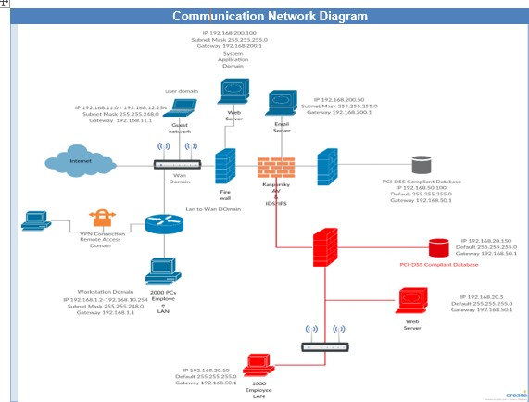

*Image 1: Communication Network Diagram*

# Hardware

User devices (laptops, computers, mobile phones), routers, servers, and gateways are examples of equipment that makes up the components of a network. In a sense, each network architecture's purpose is to discover the most effective route to transfer data from one hardware point to another.

# Transmission Media

A communication channel that transports data from the sender to the recipient is known as transmission media. Electromagnetic signals are used to send and receive data. In data communication, it is a physical link between the transmitter and the receiver.

There are two types of transmission media: wired and wireless. Medium parameters are more essential in wired media, but signal qualities are more relevant in wireless media. Bandwidth, delay, cost, and ease of installation and maintenance are all characteristics of different transmission media.

# Protocol

A protocol is a set of rules that govern how data is exchanged between devices connected to the same network. In essence, it enables connected devices to interact with one another despite variations in internal operations, structure, or design. Network protocols are responsible for allowing you to interact with individuals all over the world, and they play an important part in modern digital communications.

Network protocols enable devices to connect with one other by preset rules embedded into device software and hardware, similar to how speaking the same language facilitates communication between two humans. Without the usage of network protocols, neither local area networks (LANs) nor wide area networks (WANs) could function as they do today.

# Topology

Topologies are classified as either physical network topology, which refers to the physical signal transmission channel, or logical network topology, which refers to the way data passes across the network between devices regardless of their physical relationship.

The structure of the network is referred to as its topology. This is significant because factors such as the distance between network devices determine how quickly data can reach its destination, hence affecting performance. There are numerous network topologies, each with its own set of advantages and disadvantages.

# Step 1

Determine the performance, capacity, and network ports that your small business requires. Meet with employees from various departments to learn about their applications and prospective growth needs. Local area networks link servers, storage hardware, computers, phones, and printers to a network from a single place, such as an office or building, utilizing switches that offer ports for connecting servers, storage hardware, computers, phones, and printers. The LAN is made up of cables, switches, and routers that offer Internet access as well as routing between LAN parts.

# Step 2

Plan and construct the cable distribution system. Cabling is a vital aspect of network architecture since it offers your manufacturing organization with a physical communication channel. To reduce the risk of equipment interference, consult a cable design expert who has worked in the manufacturing industry. Consulting with a cable firm gives you piece of mind that you've chosen the right sort of cable and taken into account fire code requirements.

# Step 3

Make a spreadsheet to collect important information for the design. The number of users per site, their roles, LAN port speeds, and node kinds, such as printers and any other devices that will be connected to the network, must all be collected. PLCs for robotics and other automated systems that require network connectivity are examples of other network requirements. Create row categories for users and identify physical locations across the top columns of the spreadsheet. List the total number of users by site and classification

type (for example, office, engineering, and manufacturing). Another area of the classification should be dedicated to the computer room, with information on each server and the programs it hosts, as well as operating systems and network card speeds. Document the computer room's environmental services, such as air conditioning, electrical capacity, and humidity and temperature monitoring controls.

# Step 4

Examine the current state of the network's performance. Use protocol analyzers and network management software to conduct the analysis at various times throughout the business day, such as at the start of shifts, after lunch, and during periods when traffic is expected to spike, such as when running month-end financial processes or moving complex engineering data over the network. This activity collects data on LAN and WAN performance, protocols used, and parts of the existing topology that cause performance bottlenecks, as well as application characteristics. The protocol analyzer may be able to discover protocols that are enabled by default on some nodes and can be disabled.

# Step 5

To support the present state design, gather all of your physical and logical network diagrams. Identify routers, switches, LAN uplink bandwidth, network equipment cabinets, power and cooling data, and current fiber and copper cable plant specifications. If more than one building is present, get current IP address design information for the LAN, including virtual LAN information and connectivity requirements, for the logical design. Identify network protocols, such as routing protocols for inter-building connectivity.

# Step 6

Determine the present and predicted number of LAN switch ports for each location during the next 24 months. Even if you're talking about a tiny business, the structure may have one or more telecommunication closets known as intermediate distribution frames. If the distance from the computer room exceeds the cable constraints, the telecommunication closets deliver copper network cables to each employee's desk. The closet is also where LAN access layer switches, which provide connection ports for wireless access points,

PCs, printers, and other network hardware your company may need, are installed. Multimode fiber optics will connect the access layer switches to the computer room switches.

# Step 7

Select access layer switches based on future wireless network service, voice and video integration, and service quality expectations, as well as estimated growth requirements for network ports. This method ensures that network gear fits the company's requirements and that new capabilities may be added without compromising performance. Plan for enough fiber strands between the access layer and the computer room switches to allow for future expansion, as well as ensuring that the fiber uplinks and switch ports can handle bandwidth demands.

# Step 8

Select switches and routers, introducing network standards at each tier. Consider using a chassis-based switch for the access layer in portions of the building where future expansion and extra ports or features are required. In other regions, use smaller switches. When network hardware is standardized, it reduces variety and simplifies support because staff members are familiar with the equipment. Network switches and routers must be able to satisfy immediate port requirements and expand when new features become available. Determine whether the manufacturing section of the network will require switches that can withstand greater temperatures or if the conditions will necessitate the use of a hardened industrial-based switch.

# Step 9

Select the switches in the computer room. Examine dual switches that can support fiber connections from each telecommunication closet's access layer. In a combined distribution and core layer, plan the port density and speeds to support the servers. When using chassis-based switches, a twin switch arrangement in the computer room provides redundancy and scalability. Consider a single enterprise-class switch as an alternative to a dual switch design to save money and support future progression to a dual switch

design. Present both solutions to the management team, including the advantages, disadvantages, and costs of each.

# Step 10

Develop an IP address architecture that satisfies future growth requirements and choose a routing system for the network that supports fast convergence while remaining simple to manage. Select a network transport service and bandwidth depending on your performance requirements and growth estimates, including planned new applications, if you're designing to support several buildings. Consider the flexibility of the service to support bandwidth modifications to meet future requirements when choosing WAN transport to connect buildings.

# Implementation Framework Step 1

Implementation should be done in stages. First, connect the servers to the computer room core switches. It may be possible to implement the new access layer switches on the same day, depending on the size of the firm and the business process requirements. Following the installation of the core switches in the computer room, schedule wide area connectivity at a time that does not interfere with the access layer installation. Coordinate wide-area connectivity with the telecommunications provider of this network service.

# Step 2

All personnel should be informed about the extent of each phase's implementation, as well as the dates and hours. When new equipment is installed, it usually means that systems and data are unavailable at the time of the transition. Employees can organize their work around the downtime that results as a result of this.

# PROTOTYPE APPLICATION Physical Network Design

The core, distribution, and access layers are used in the majority of campus networks. Depending on the size of the networks, these layers (illustrated in Image 2) can be spread out into more or compressed into fewer. To facilitate data handling and routing within campus networks, this three-layer network layout is used.

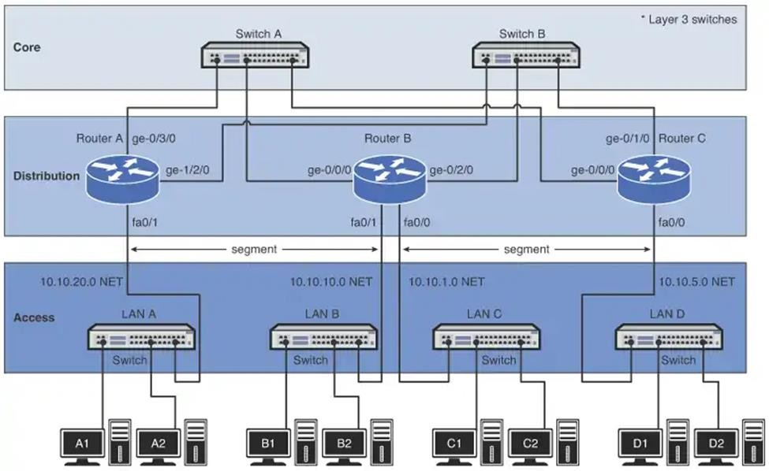

# 5.0 Recommendations and Conclusions

Banking system is a group of networks of institutions that provide financial services to people. Bank institutions are responsible for operating a payment system, providing loans, taking deposits, and helping with investments. The system will make the process faster and more convenient for users. Develop a good and dependable system in order to achieve customer satisfaction.

The project will help the authorized personnel to collect and transact in a faster and efficient way. Managing the collection will never be burdensome for the system had its function to manage all the transaction. The project team ensure that the sprint and deliverables met its requirement and work its functionality. But the project team still consider further improvement for the developed project.

# Appendix A. – Curriculum Vitae



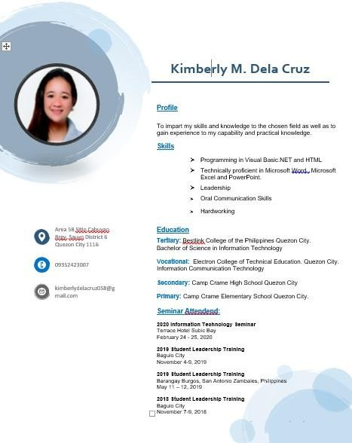



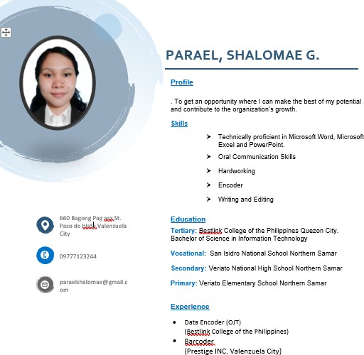

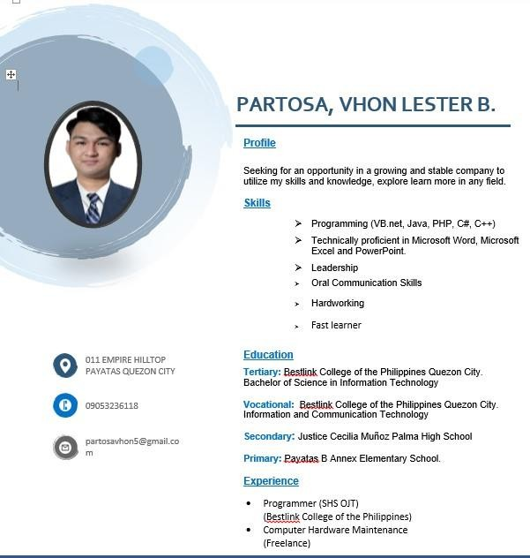

**Final comment**

**Legal Management**

Legal management should be connected to logistics 1 for bidding.

You should improve the security features knowing that your EIS is banking/Additional security features.

The Legal Management should be connected to Core transaction 2 for the consolidation of accounts.

The Legal Management is also connected to customer relationship management for filing complains and that legal management will provide legal action.

# Document Management

Document Management should a have a copy of all transactions performed by submodules.

# Facility Management

Facility Management is connected to warehousing for the equipment document repository.

Facility Management is also connected to maintenance repair and overhaul for requesting maintenance.

# Appendices J - Photos During Authorship and Oral Examination

